Fashion Shop

Database class project, academic year 2023 /2024

|  |  |  |  |  |
| --- | --- | --- | --- | --- |
| Student Name in English | Student Name in Arabic | Student ID | Section time as shown in zajel | Work percentage |
| Shahd Almasri | شهد المصري | 12112962 | 9-8 | 50% |
| Samia Asmar | سامية اسمر | 12113993 | 9-8 | 50% |
|  |  |  |  |  |

Date 2-12-2023 / time

---------------------------------------------This section is intended for the Instructor---------------------------------------

|  |  |
| --- | --- |
| **Topic** | **Mark** |
| Project Requirements and Modeling |  |
| Correctness of Database mapping |  |
| Functional Dependency and Normalization |  |
| Project Tools |  |
| Project Discussion |  |
| Project Completeness |  |
| Project Output Results or reporting (JasperReport, charts, graphs, etc.) |  |
| Project Administration and Management |  |
| Project Report |  |
| Project Idea |  |
| Project Complexity |  |
| Team work |  |
|  |  |
|  |  |
|  |  |

Abstract

The project talks about a clothing institution, and this website is dedicated to the administrator, as it contains information about each branch, departments, products, import companies, and employees. He can add, modify, and delete any information, calculate the salary of any employee he wants, and know how many products each section contains.

Table of content

|  |  |
| --- | --- |
| Abstract | 2 |
| introduction | 3 |
| Requirements | 3 |
| Functional Dependency | 5 |
| EER & UML & mapping | 8 |
| BCNF | 11 |
| Tools | 11 |
| discussion | 12 |
| conclusion | 54 |
| references | 55 |

Introduction

Our clothing store management database is a solution designed to simplify the process of storing information while keeping it intact and not losing it. It enables us to easily modify any information and display any data we need. We perform all these operations by linking the database with a GUI that facilitates the dealing process, and all this information is linked to each other. For example, when adding a new worker, the department and branch in which he works must be available, so it is not possible to add a worker to a branch that does not exist in the first place, and so on.

Our program helps by knowing a lot of information, for example during the inventory process, showing us all the departments containing the goods, as well as the process of creating reports or invoices for sale and other operations provided by the database.

​

​

Institution data requirements

**This is institution clothes:**

1. The institution consists of several branches, each branch is managed by a director, his deputy, and employees where each branch has its own name, number, and manager.
2. The branch consists several departments, each department has a name and number, each department consists of products. We have more than one department, and each department is dedicated to a specific category.

(We can calculate the number of products in each department).

1. We store each employee’s name, number (ssn), email, location, name of department, name of branch they work in, gender, birth-date, hours work.

(The employee receives his salary according to the number of hours he works).

1. Each branch has a product we store his name, size, color, year of purchase, par code, price, quantity, picture and packaging reference.

1. The products are import from many packaging reference and we store the city of import, name of company, email, number and date.

Functional Dependency

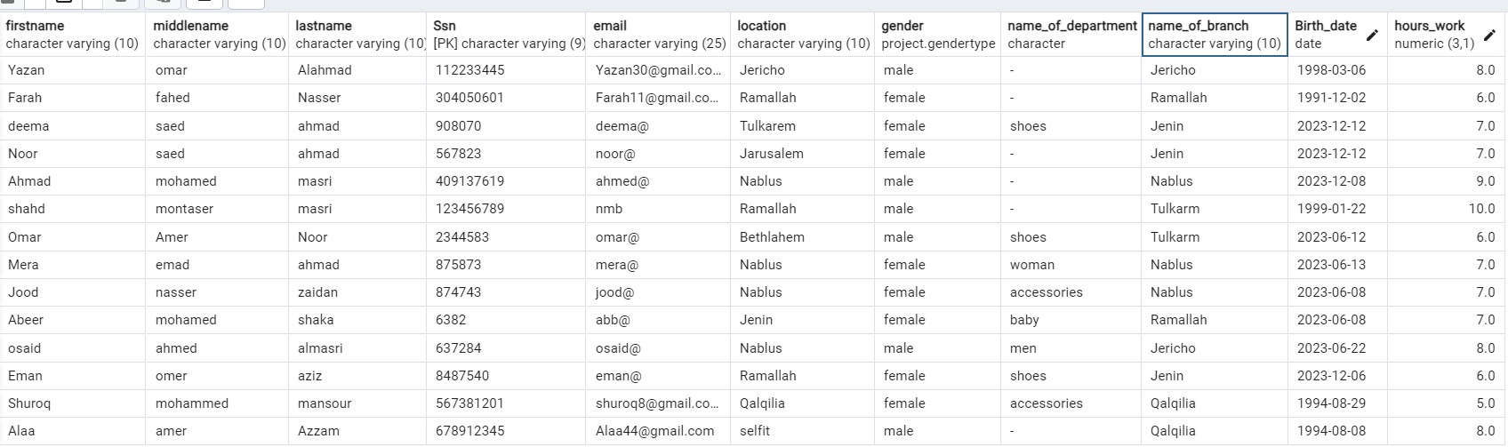**employee**

Ssn 🡪 firstname Ssn 🡪 gender

Ssn 🡪 middlename Ssn 🡪 name_of_department

Ssn 🡪 lastname Ssn 🡪 name_of_branch

Ssn 🡪 email Ssn 🡪 Birth-date

Ssn 🡪 location Ssn 🡪 hours_work

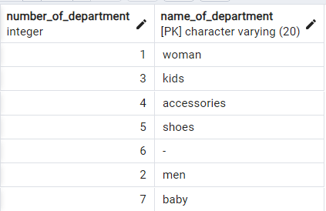**Department**

number_of_department 🡪 name_of_department

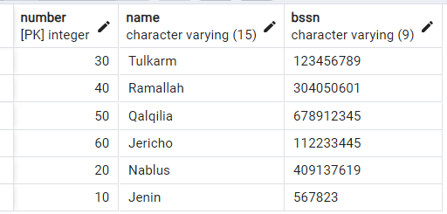**branch**

number 🡪 name

number 🡪 bssn

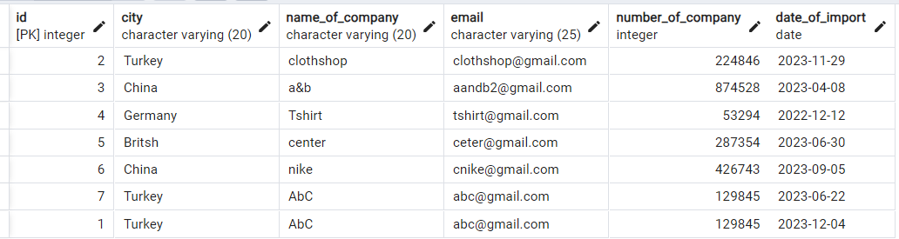**import**

id 🡪 city

id 🡪 name_of_company

id 🡪 email

id 🡪 number_of_company

id 🡪 date_of_import

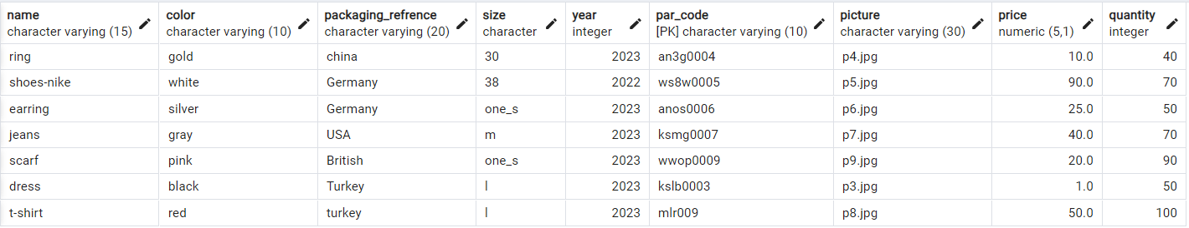**product**

par_code 🡪 name

par_code 🡪 color

par_code 🡪 packaging_refrence

par_code 🡪 size

par_code 🡪 year

par_code 🡪 picture

par_code 🡪 price

par_code 🡪 quantity

EER and UML

UML

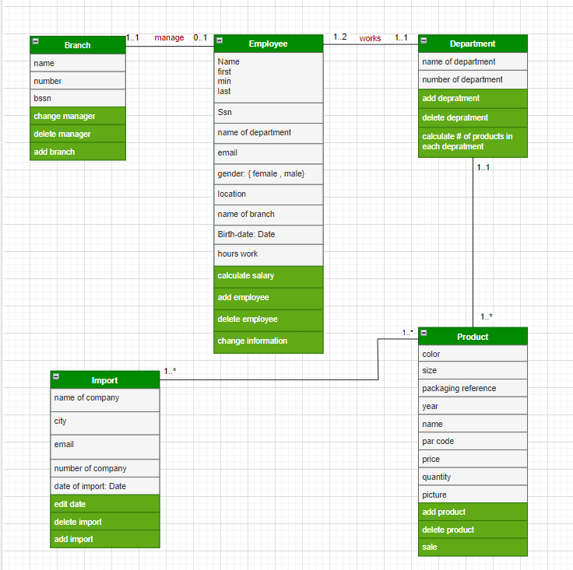

CROWS

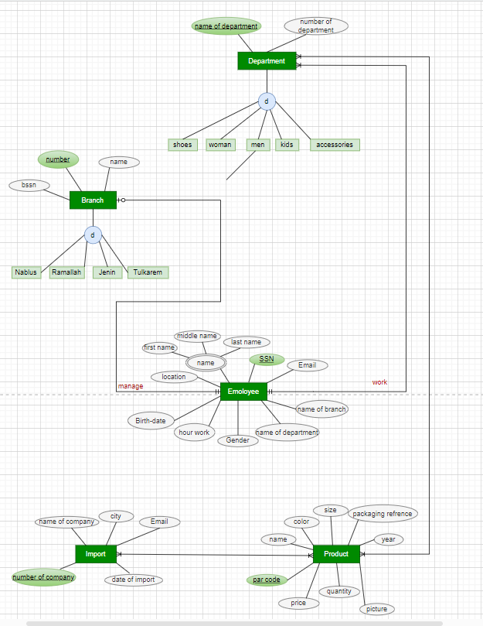

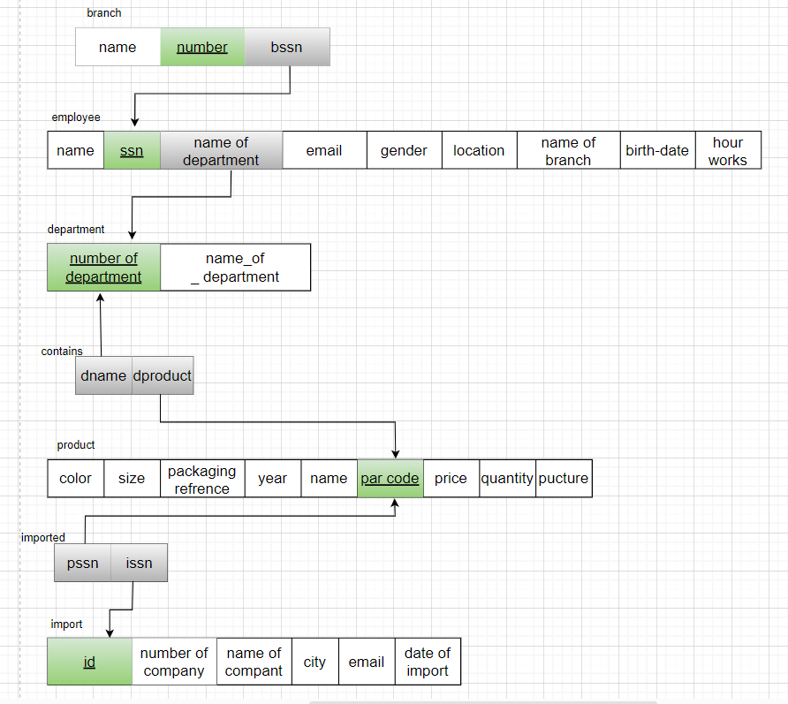Mapping

BCNF

Boyce-Codd normal form (BCNF): In this table every determinant is a candidate key, so employee table in BCNF.

Boyce-Codd normal form (BCNF): In this table every determinant is a candidate key, so department table in BCNF.

Boyce-Codd normal form (BCNF): In this table every determinant is a candidate key, so branch table in BCNF.

Boyce-Codd normal form (BCNF): In this table every determinant is a candidate key, so product table in BCNF.

Boyce-Codd normal form (BCNF): In this table every determinant is a candidate key, so import table in BCNF.

Tools

Pgadmin4

Netbeans

JasperReport

Drowio

Stack Builder

discussion about your project GUI work

note: 🡪 if name_of_department = (-) this employee is the manager of branch

This program only for the manager of any branch can be logged in.

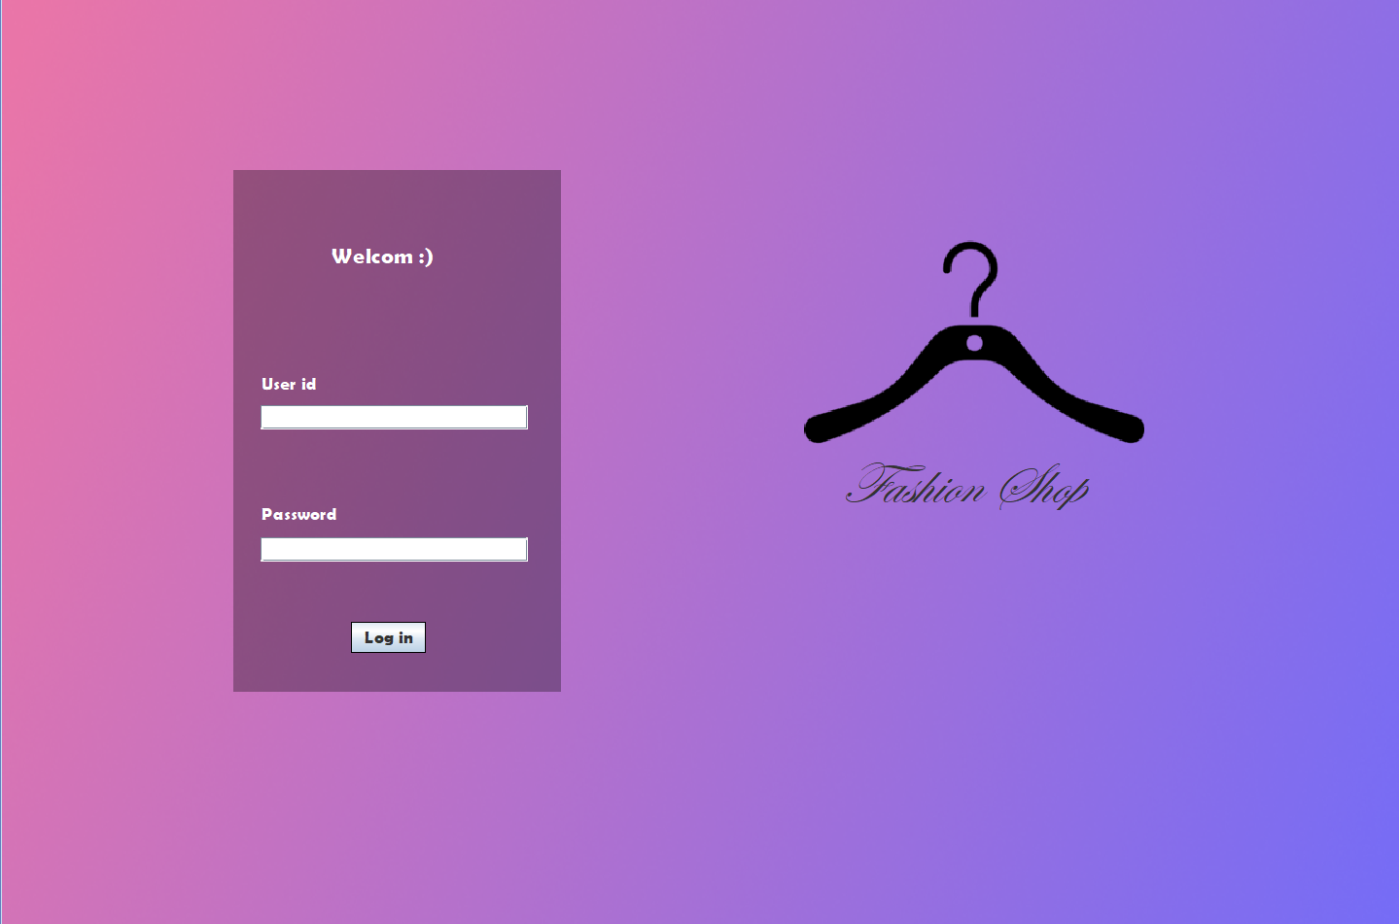This the log in interface.

If you want to move to home page you want to be manager ( your department name should be = (-) and the password for every manager is = (12345678) .

If you enter incorrect password or id or forget to enter id or password will apper to you JOptionPane show enter correct

For ex. This id is not for any manager

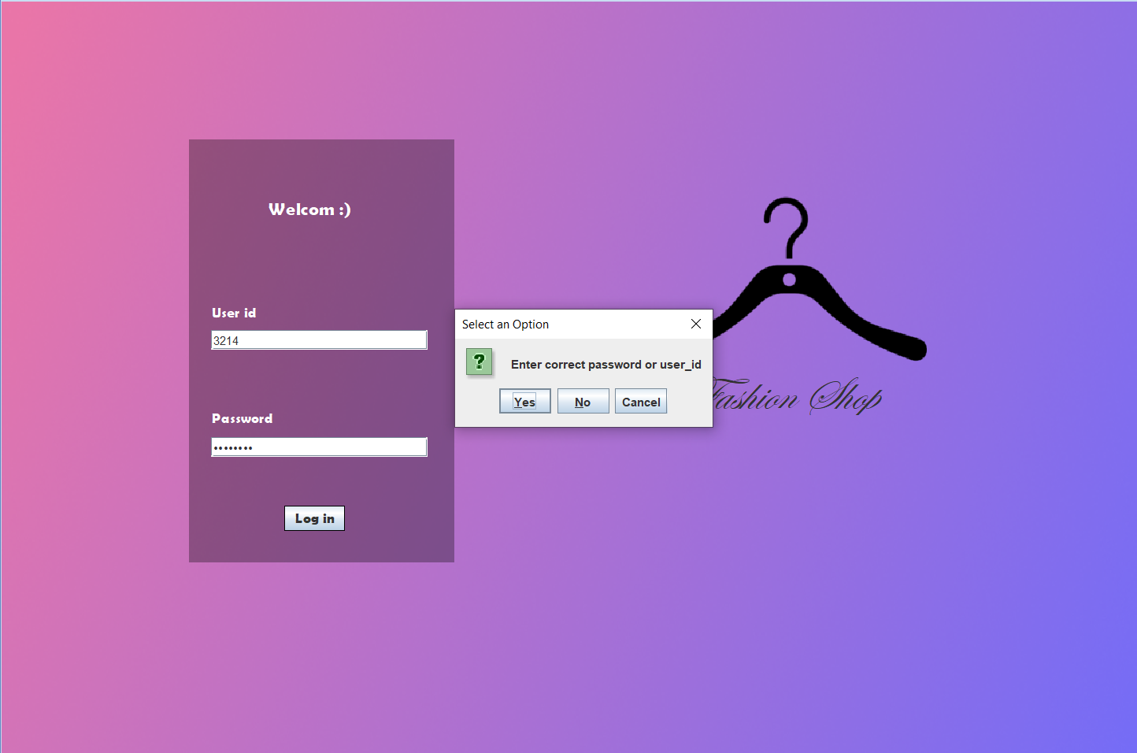

For ex. This id is for any manager but password != 12345678

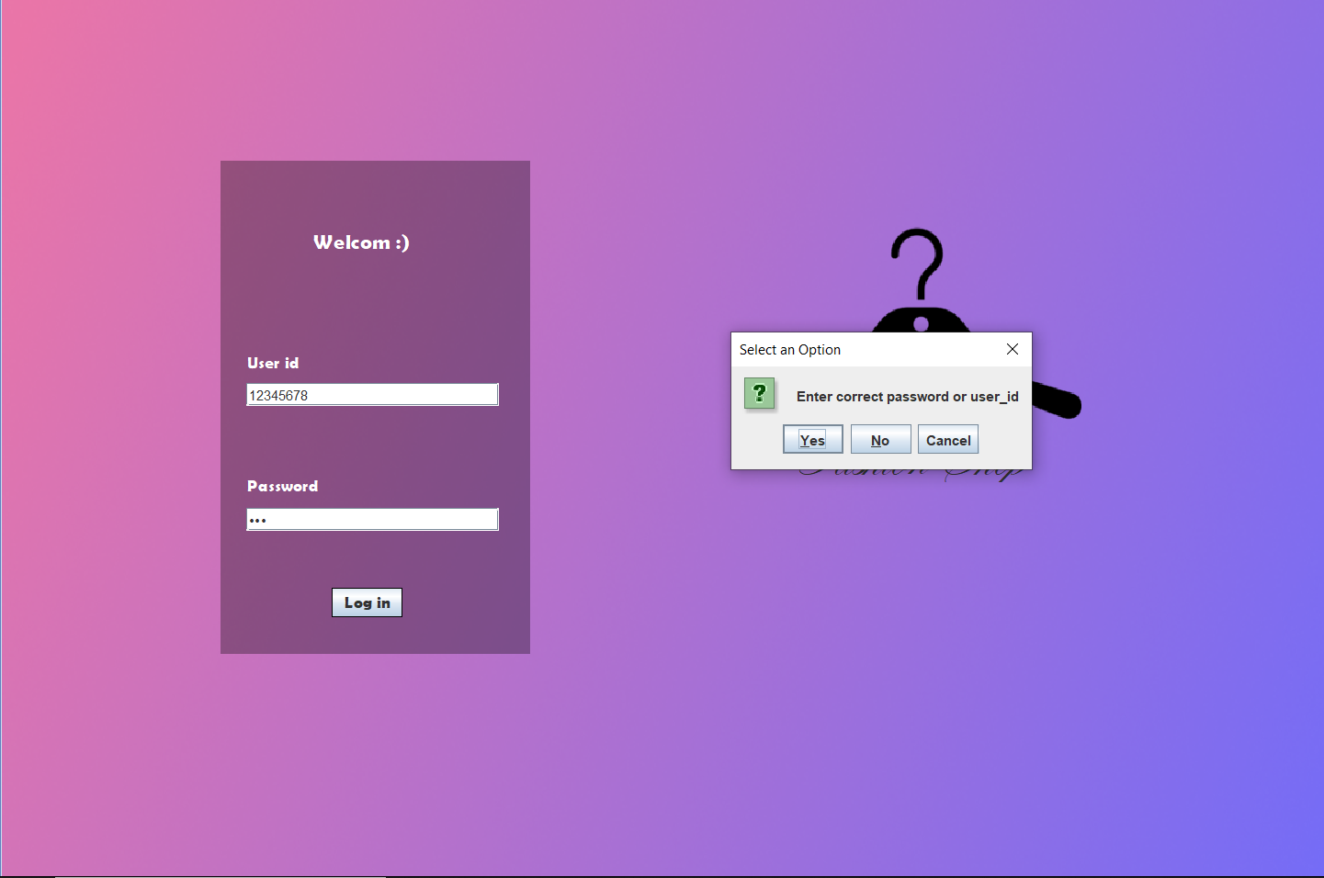

For ex. Forget to enter id

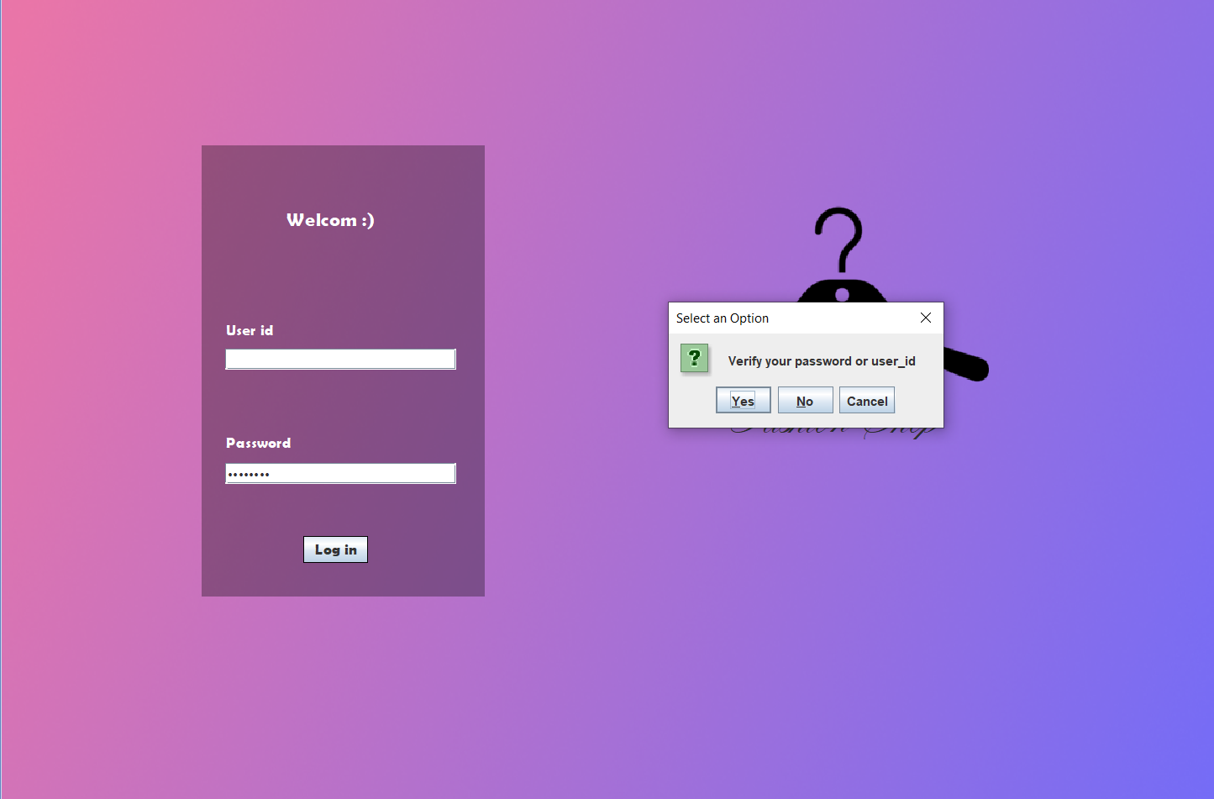

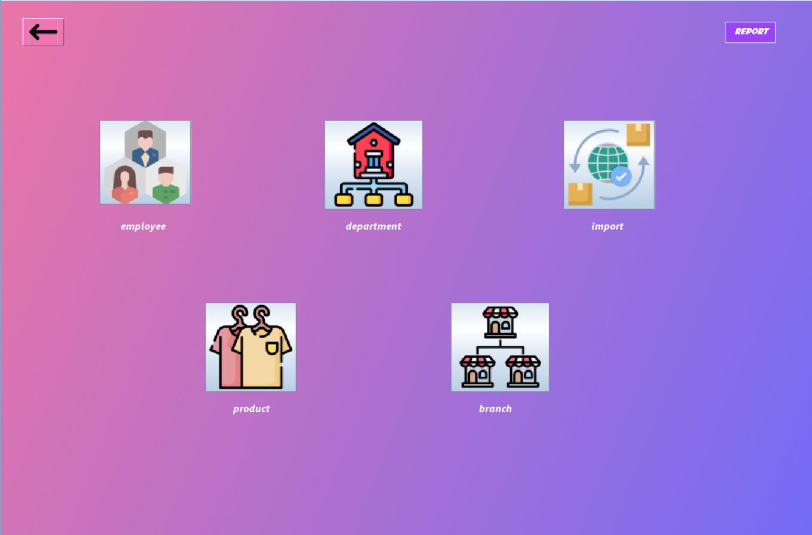Enter correct value

After enter correct value I move to the home page.

Home page have many buttons I will explain each button:

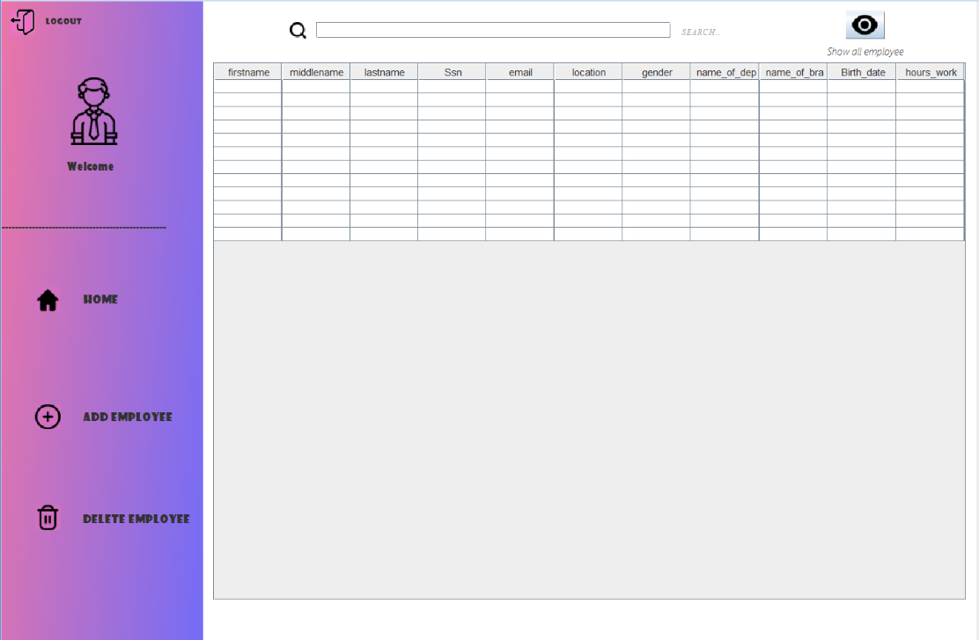If I pressed on employs button this page will appear



If click on Home button 🡪 go back to home page

If click on logout button 🡪 go back to login page

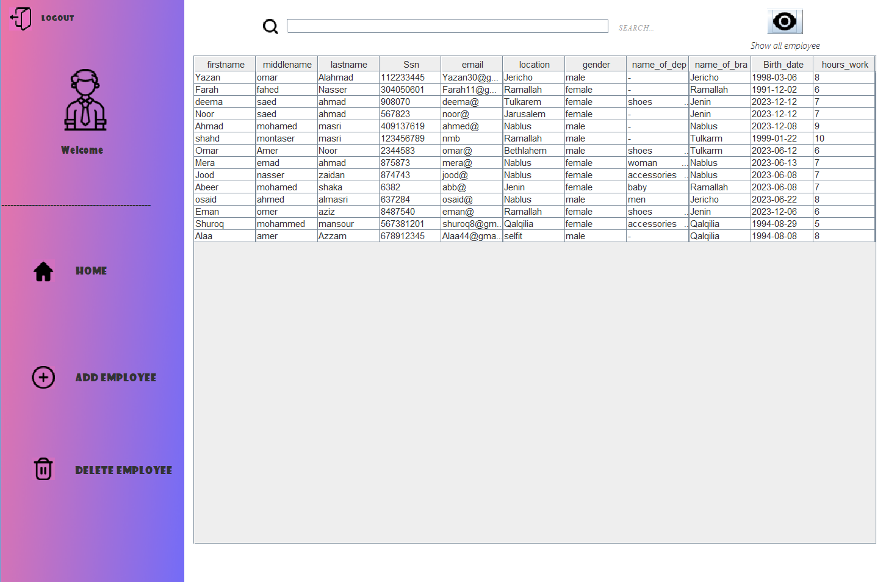If pressed on show all employee will appear :

You can search about any information of employee for ex.:

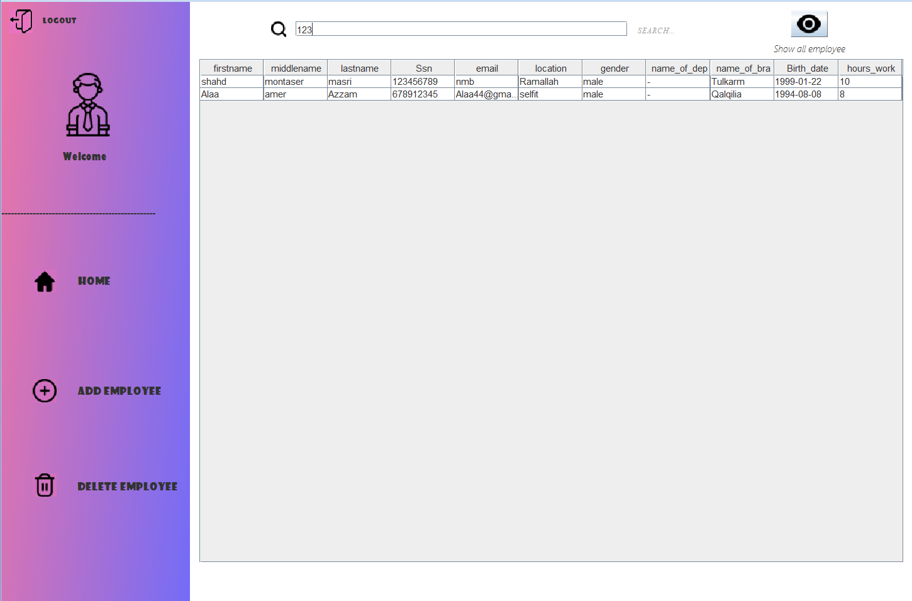

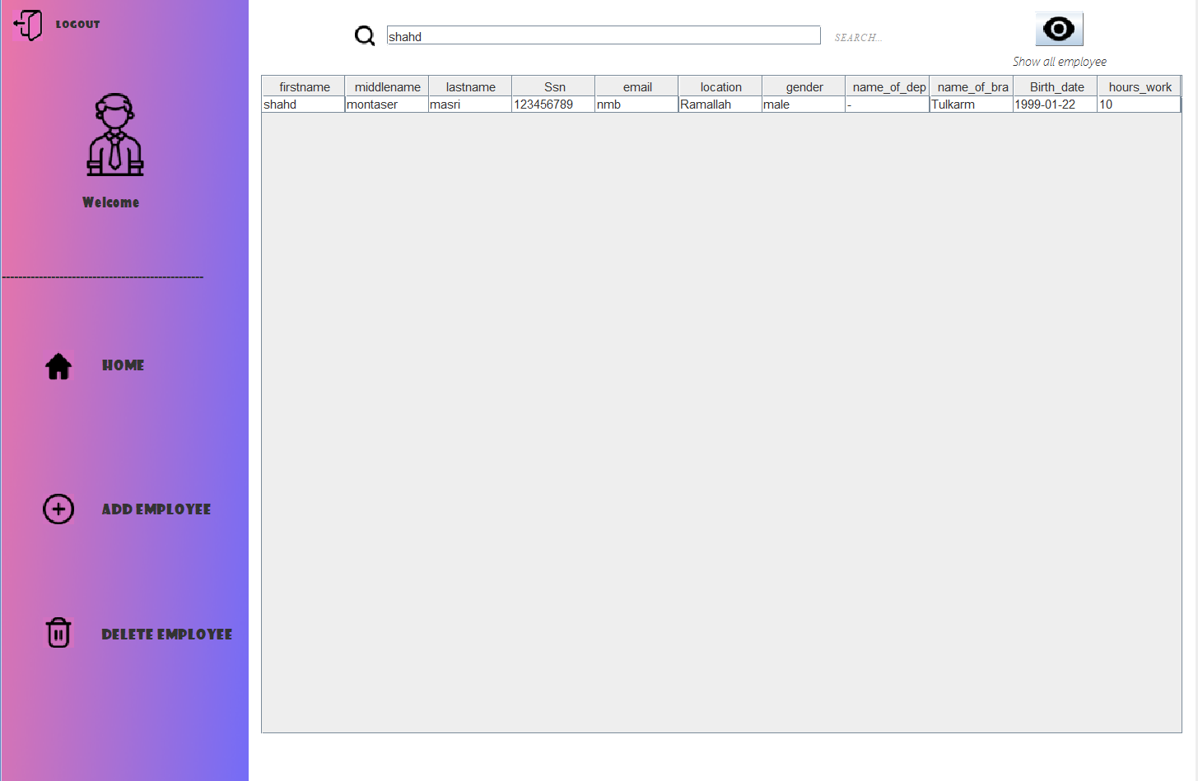

If click on this button will appear panel that contains many textField to enter the information about the new employee

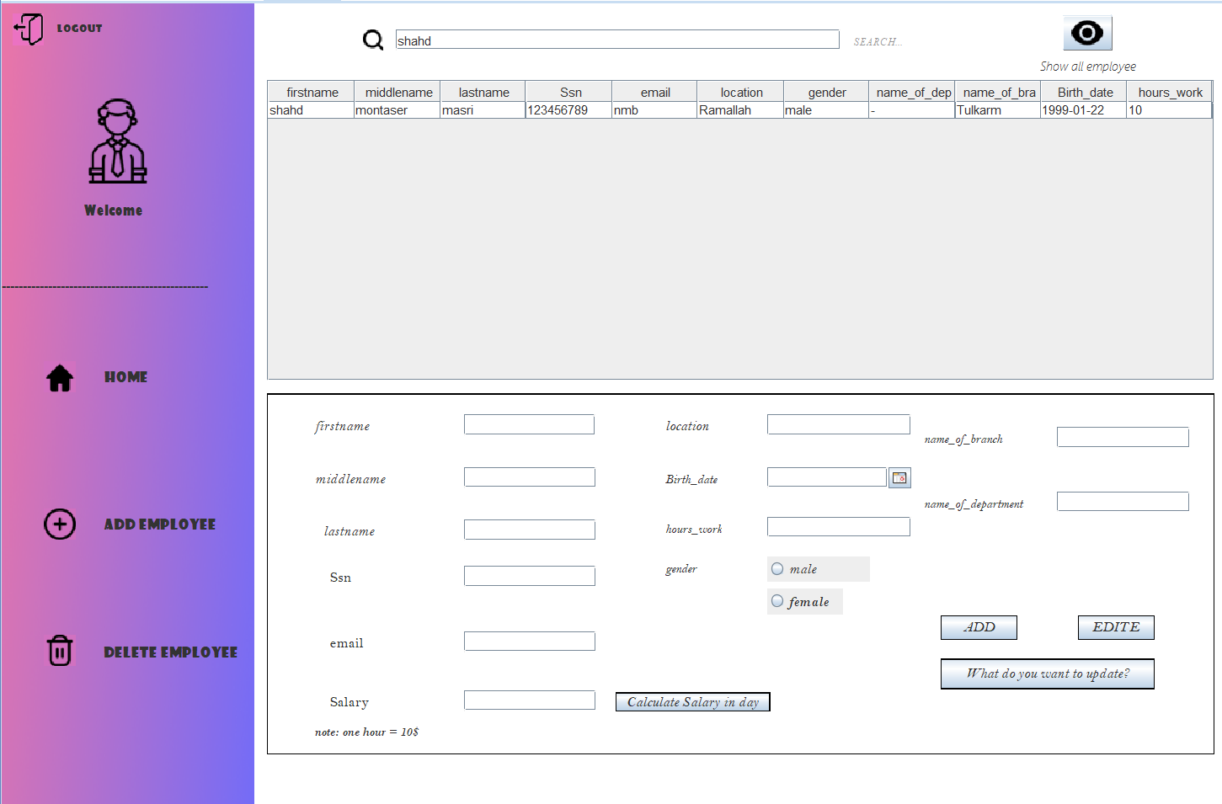

Not if you ignore to determines the gender will appear to you JOptionPane show (enter the gender)

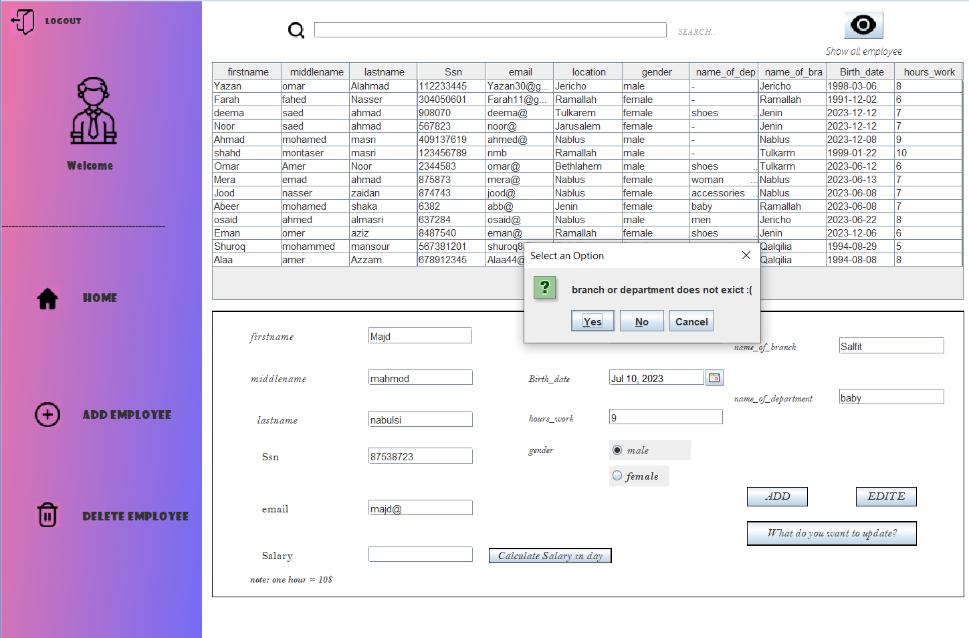Also if you add employee to branch or department not exist will not add ex.

Example of add new employee

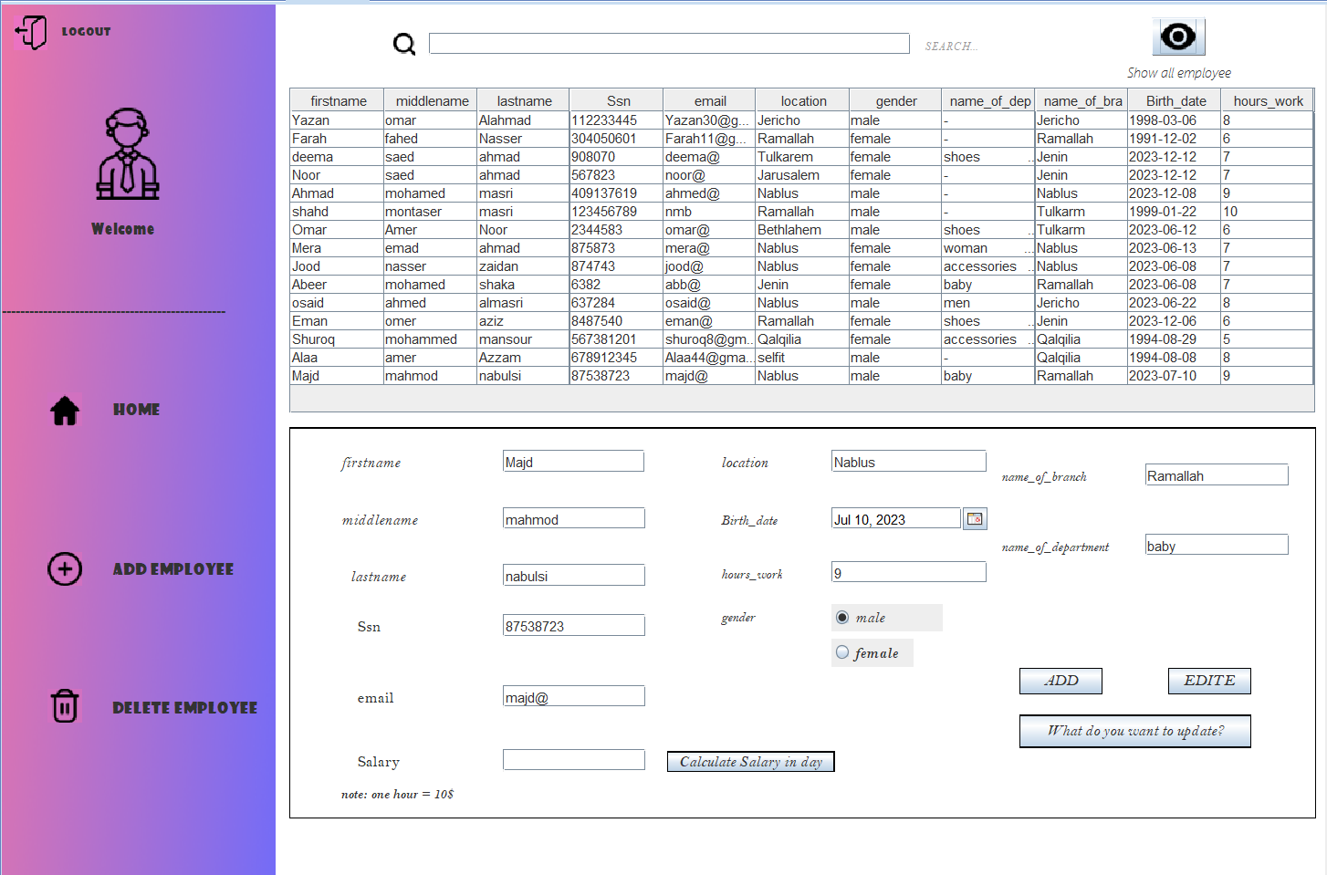





If click on will delete employee based on Ssn there example:

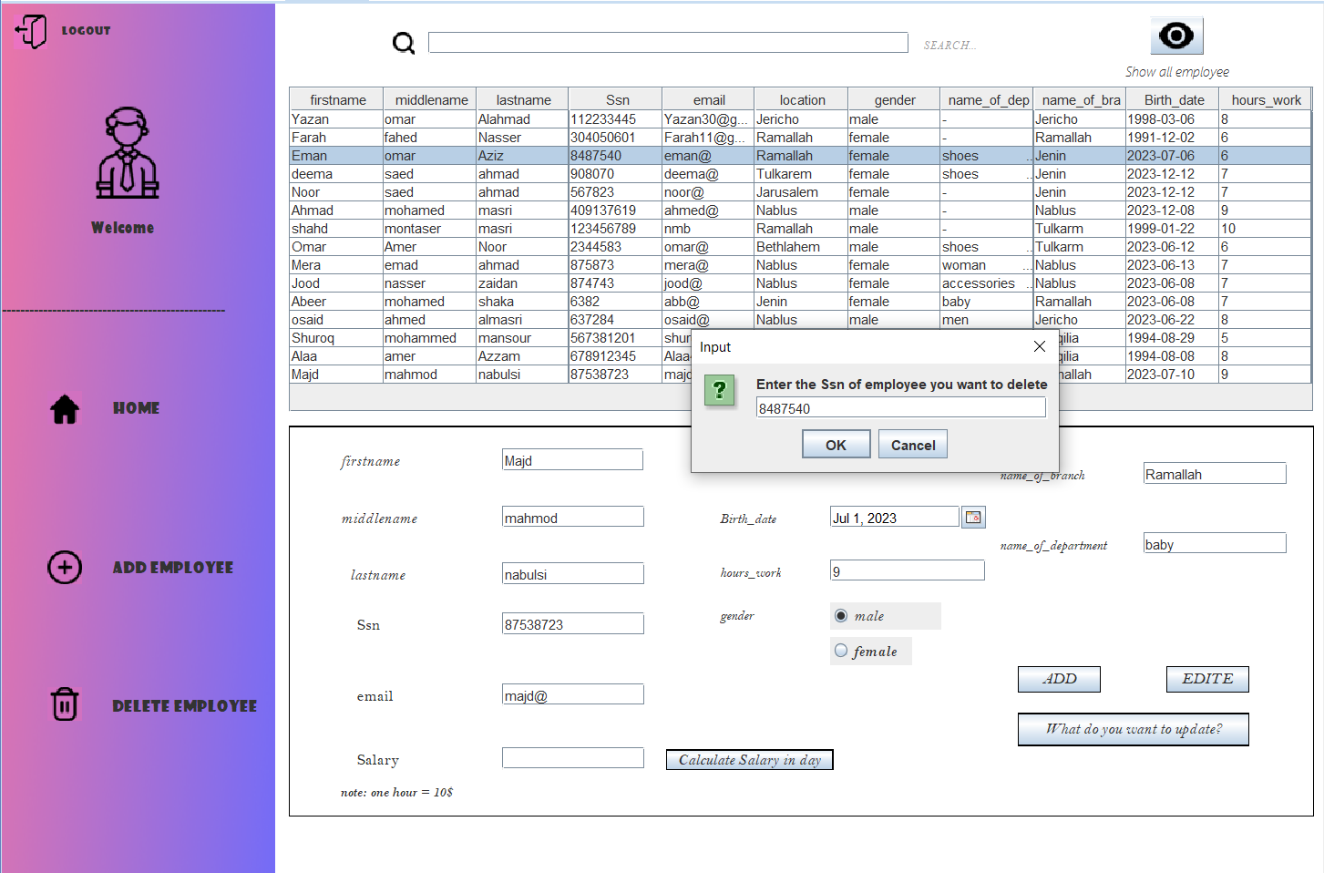

There’s the result

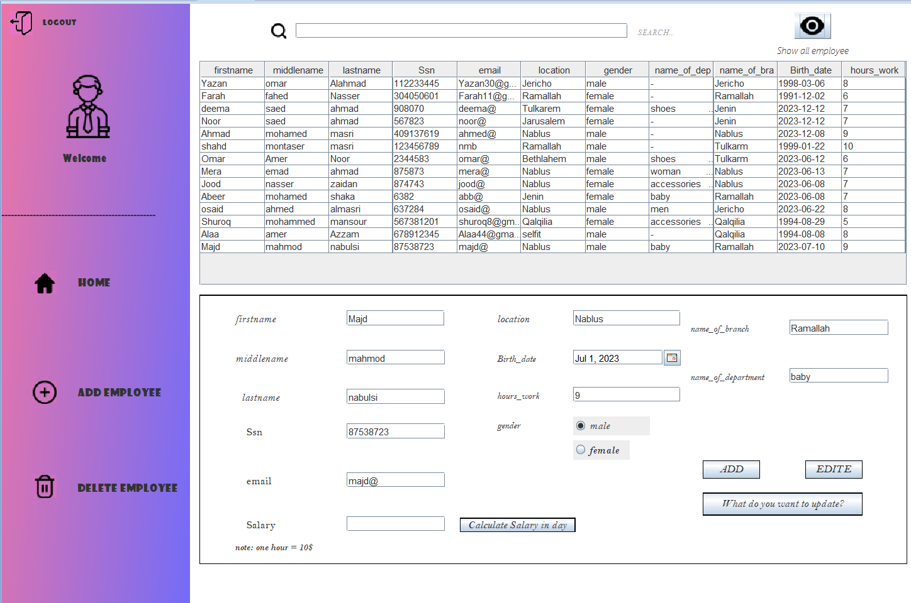

If click on button (What’s do you want to update?)

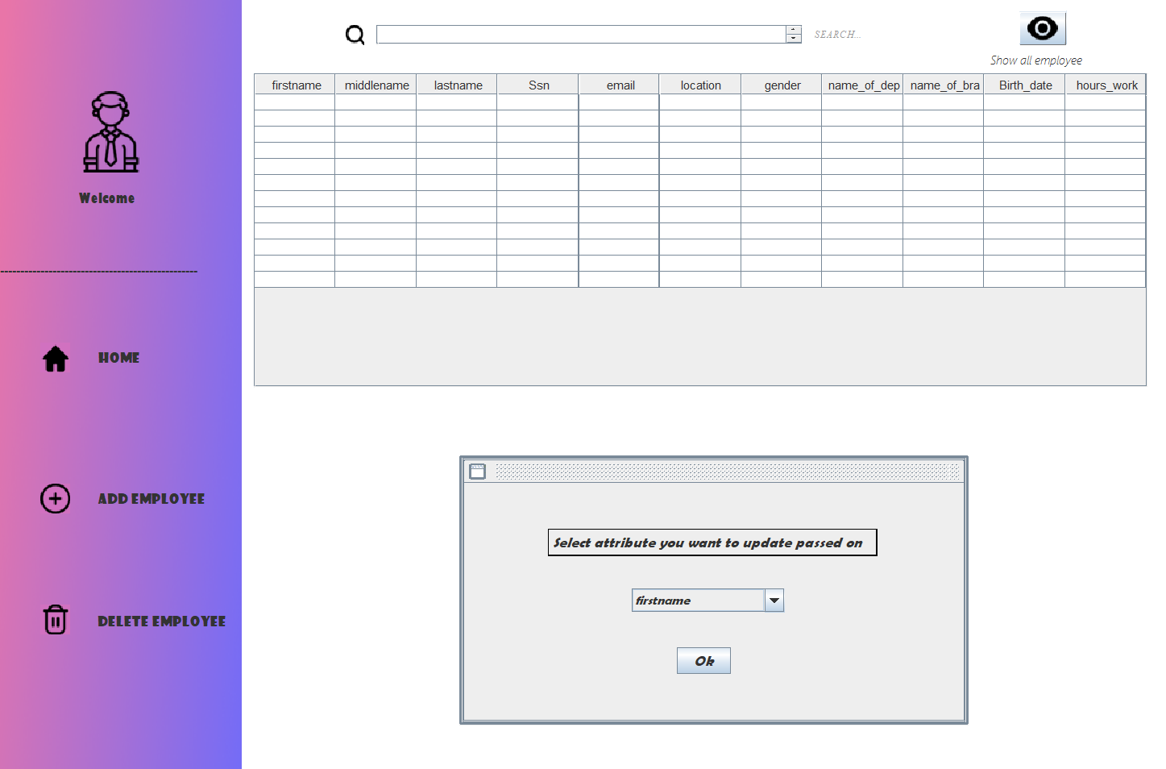Will to frame to choose what information you want update passed on Ssn there’s ex. :

Then I choose to update the lastname then click on ok button

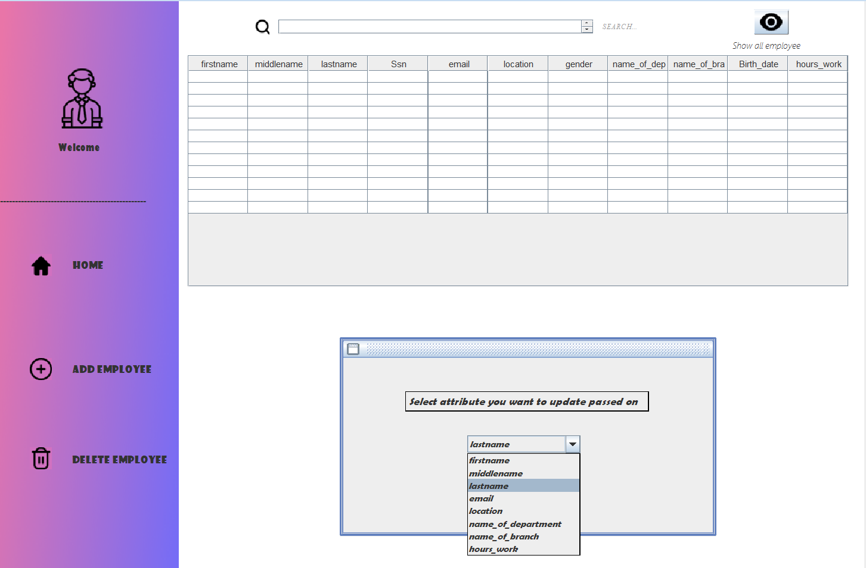

Then go back to employee page and click on (Edite) to enter the information

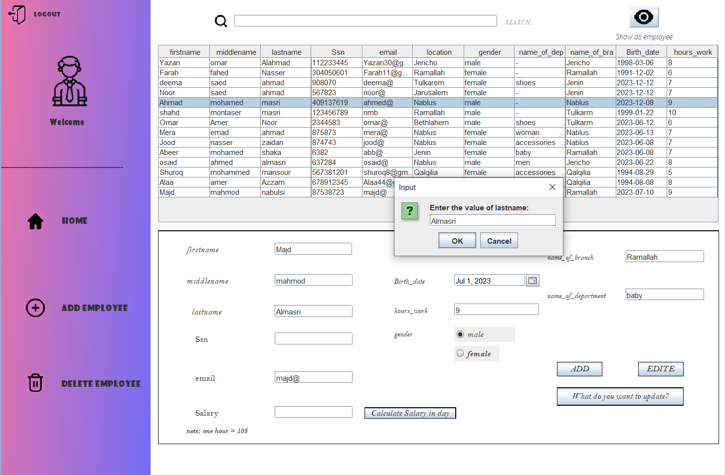

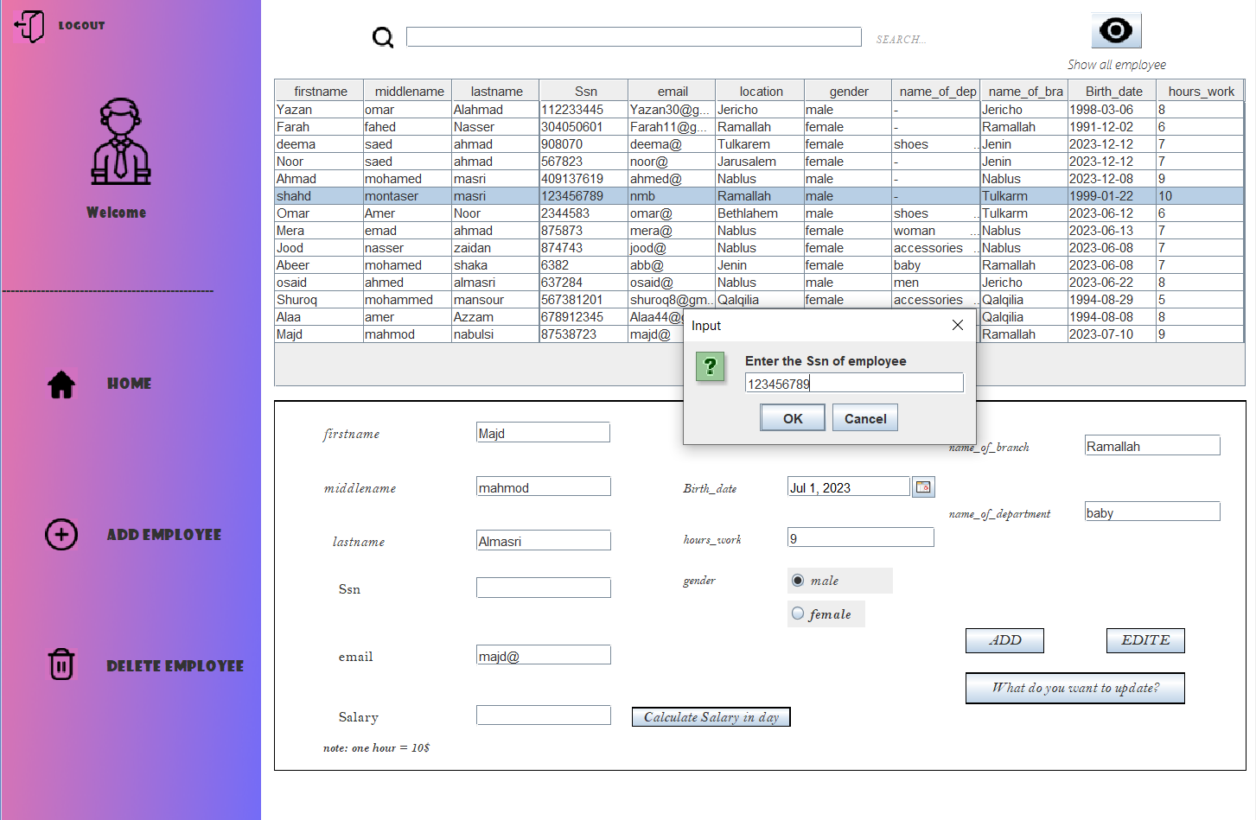

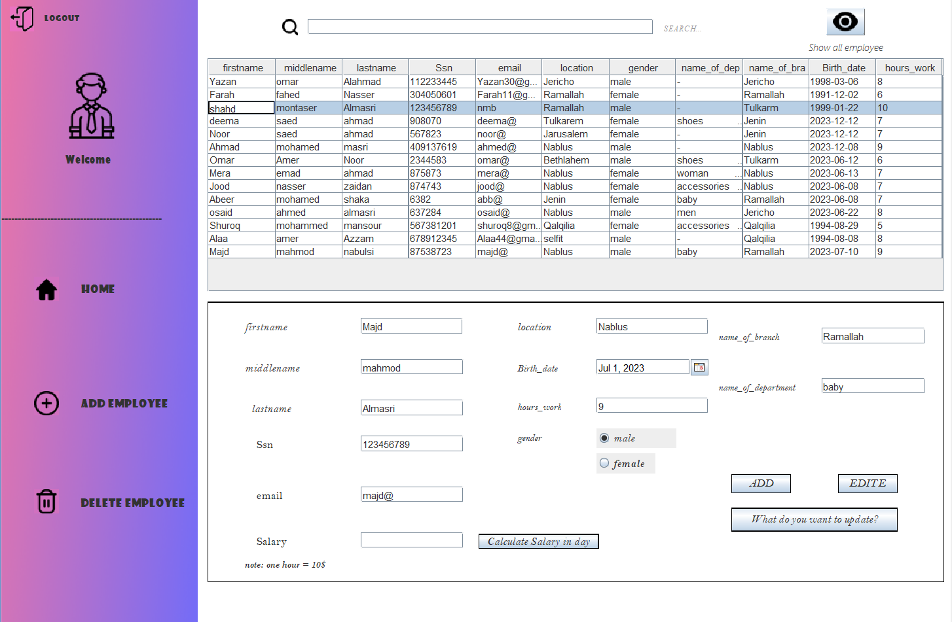



If I click on (Calculate Salay in day) not that the one hour = 10$

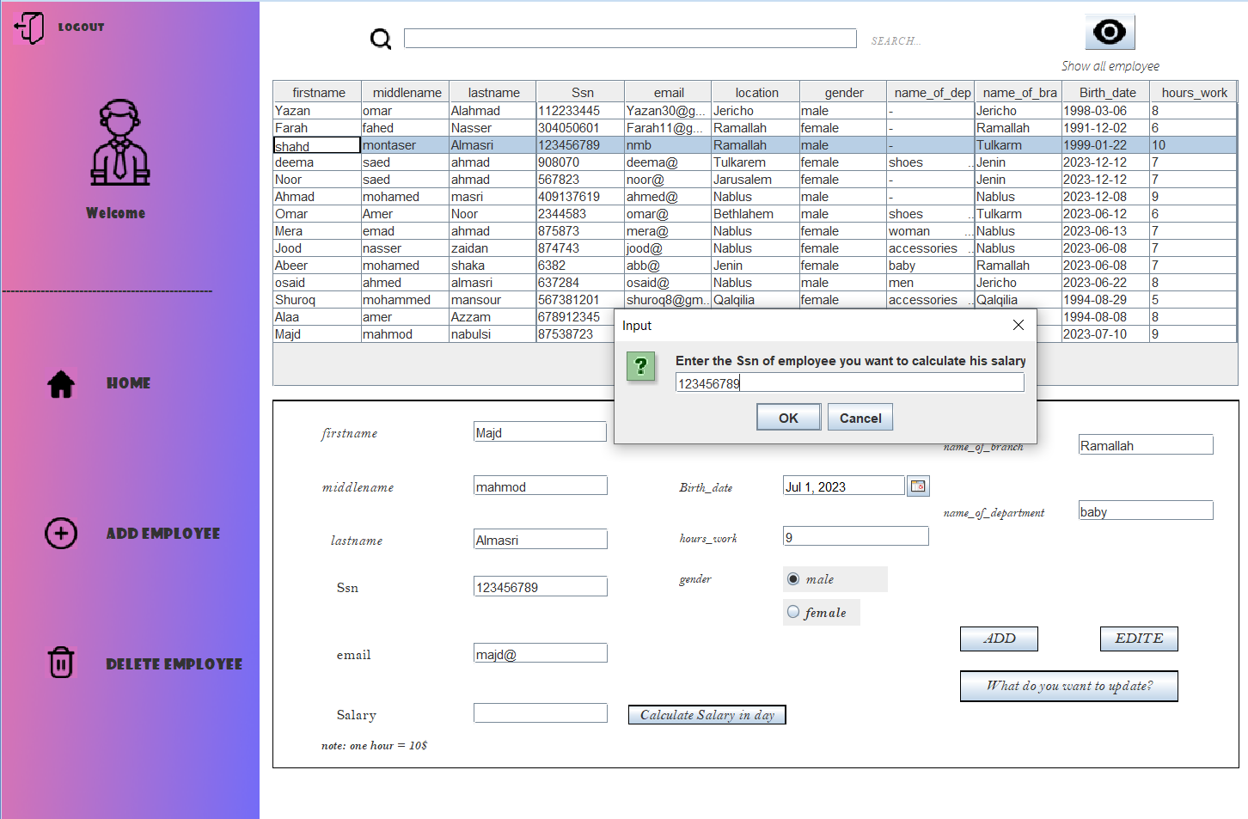“the calculate of salary id based on Ssn” there ex. :

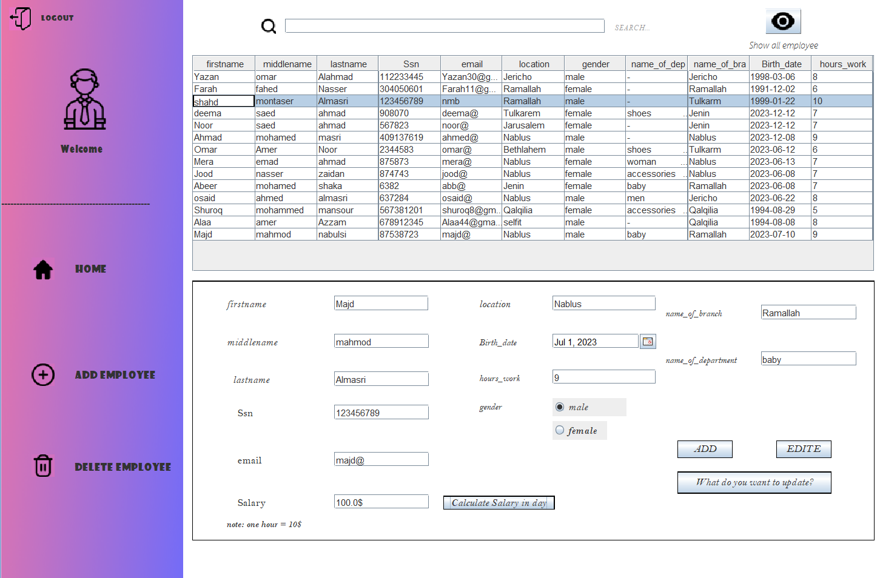



If I back to home page and pressed on department will move to department page

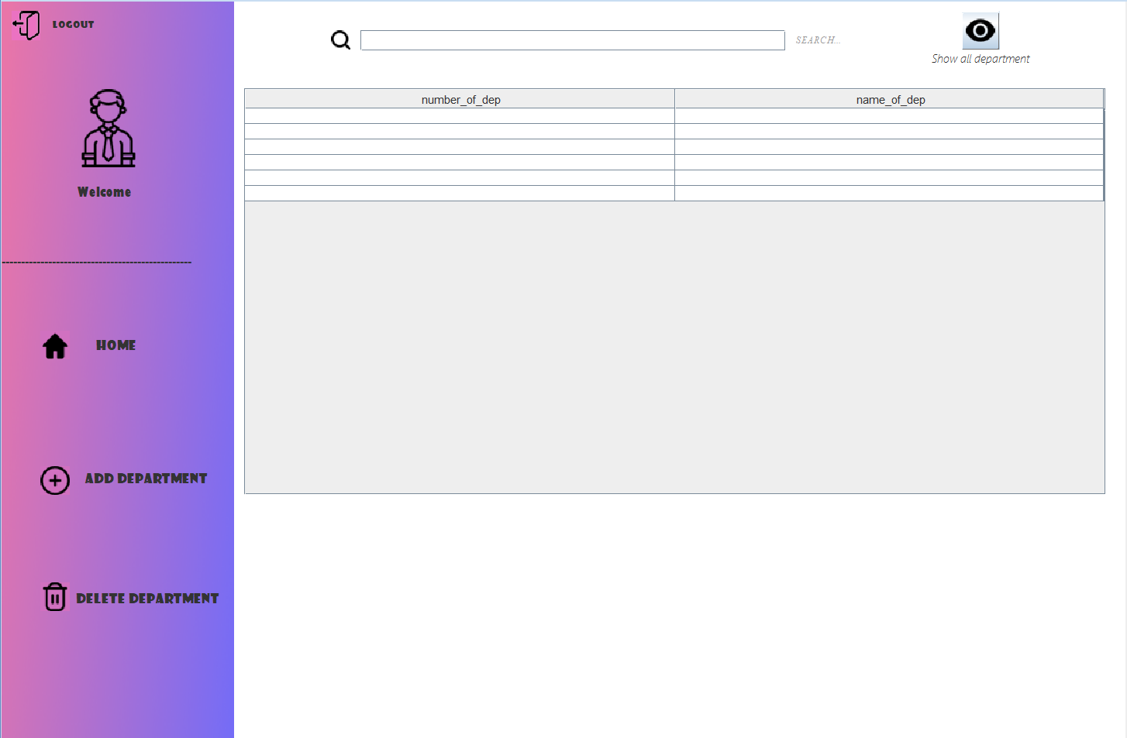



If click on Home button 🡪 go back to home page

If click on logout button 🡪 go back to login page

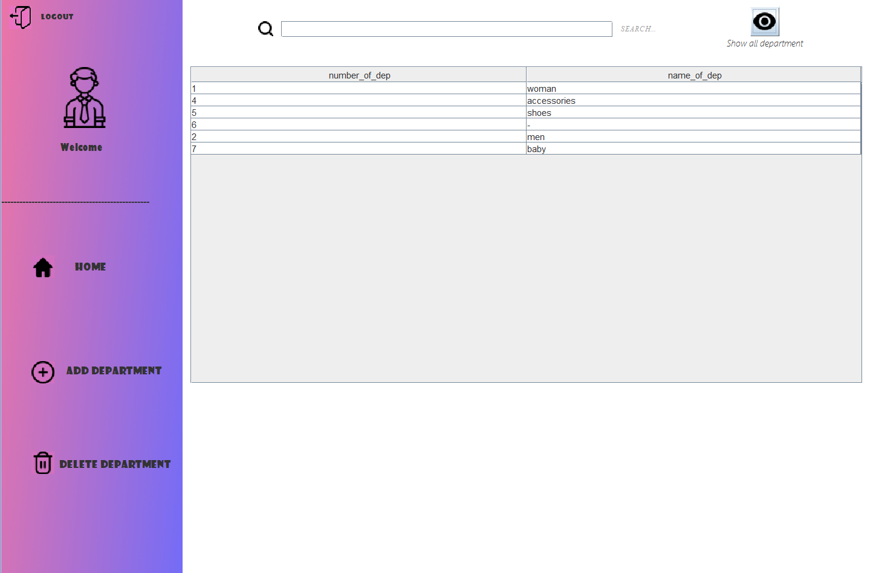If pressed on show all employee will appear:

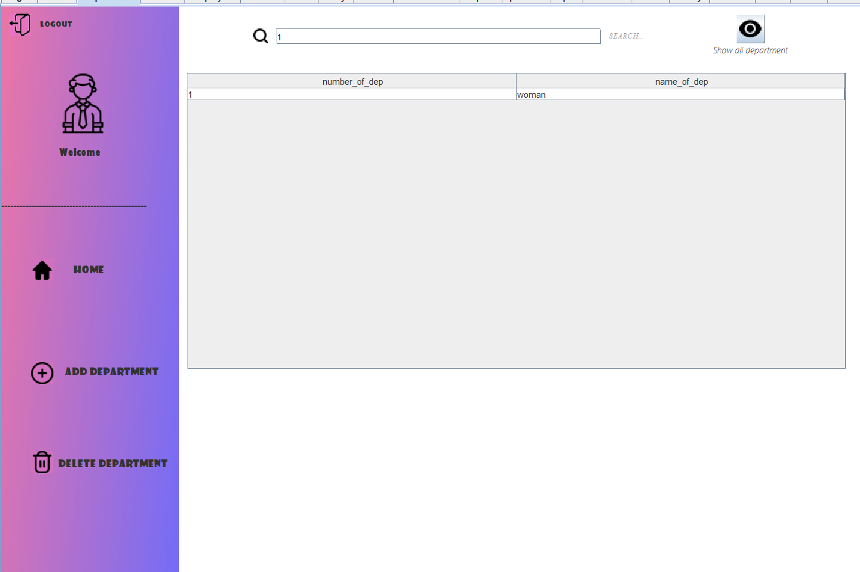You can also search about any department example:

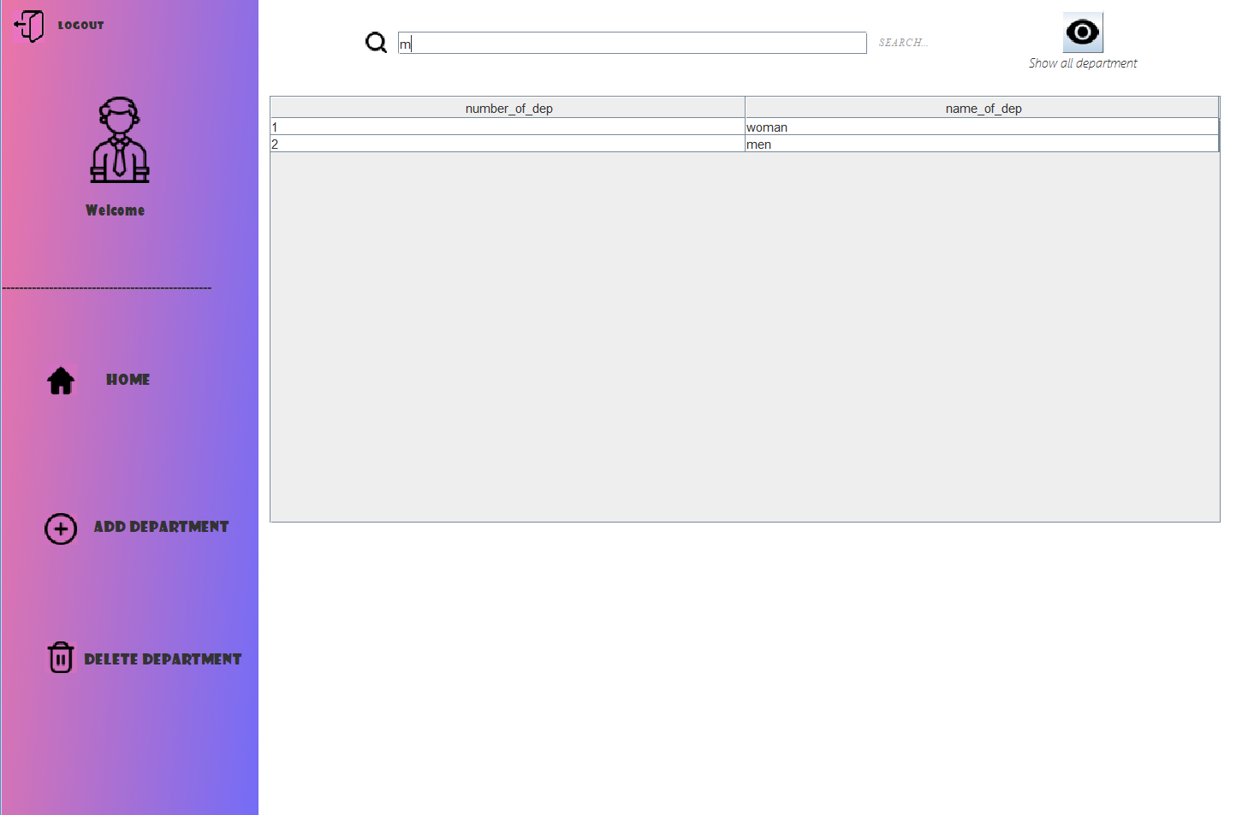

If pressed on then appear the panel to enter the new department:

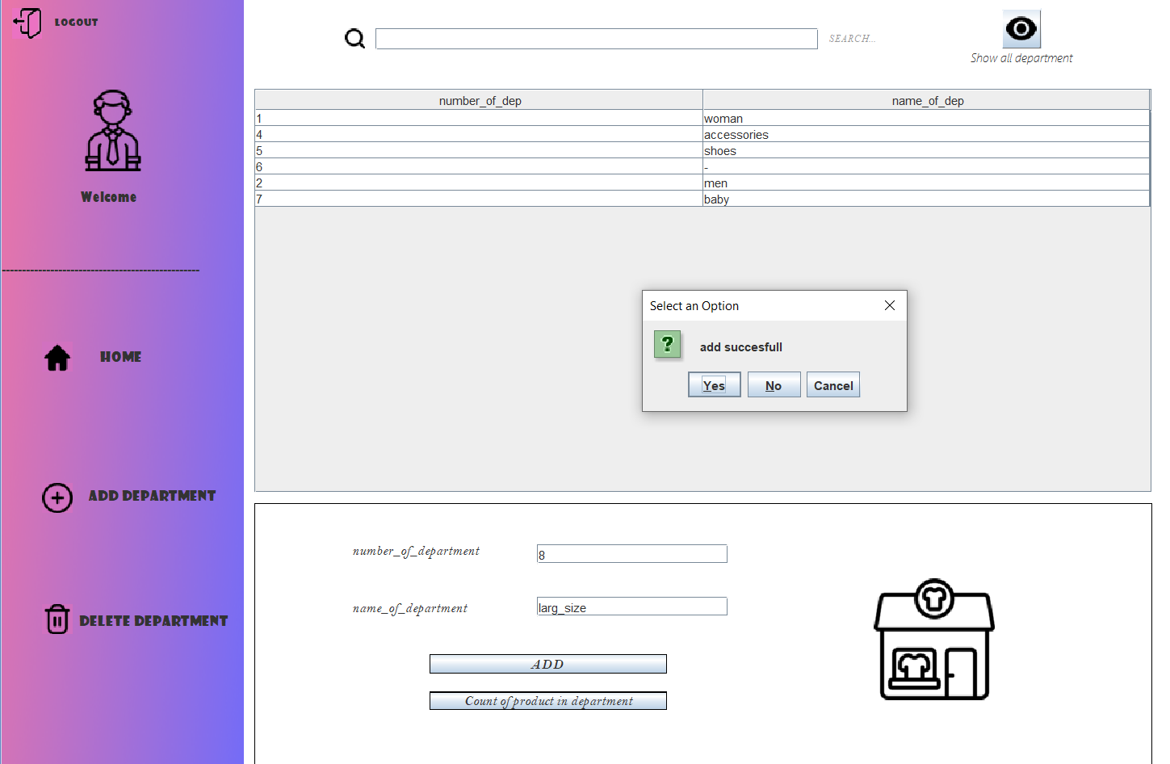

The result

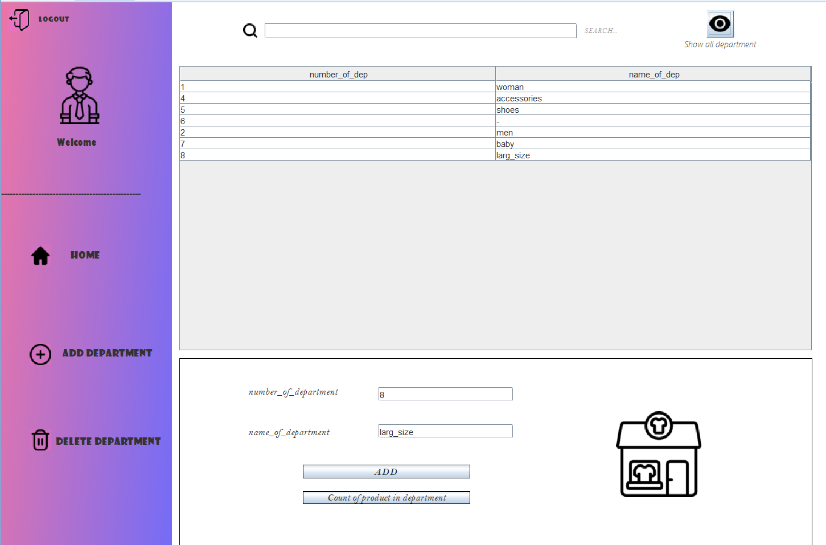



If I pressed on then you can remove any department based on name_of_department

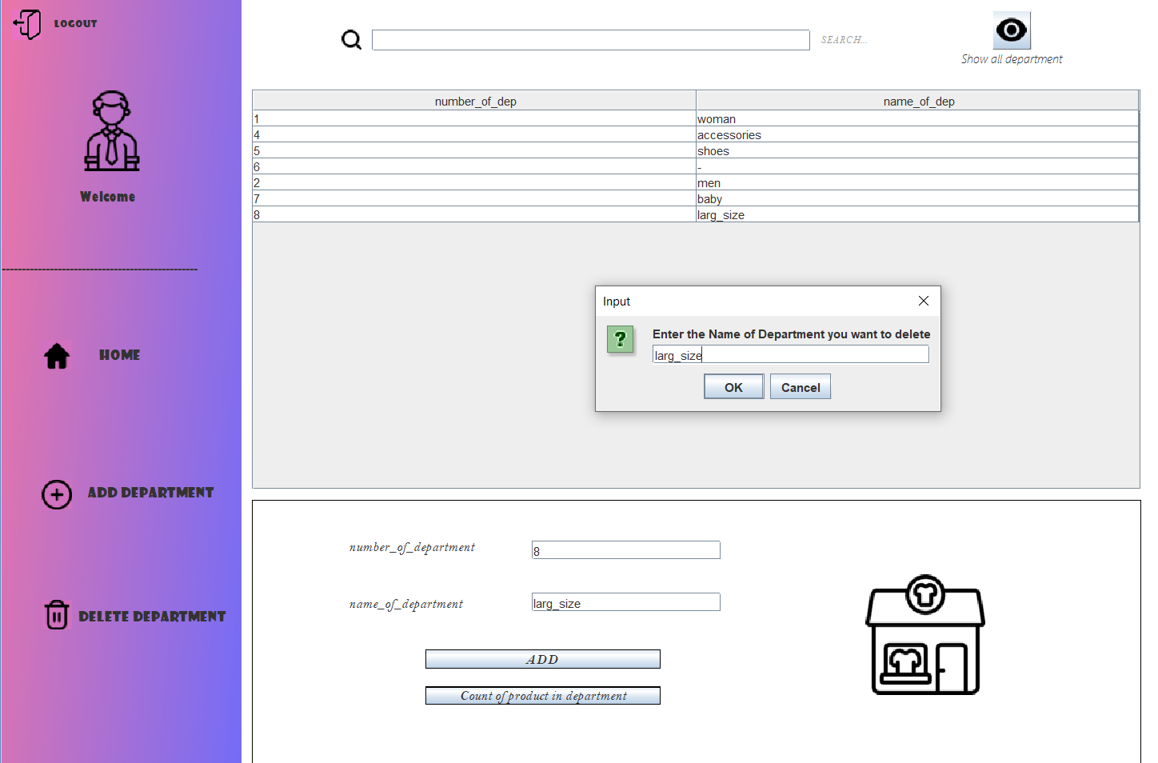

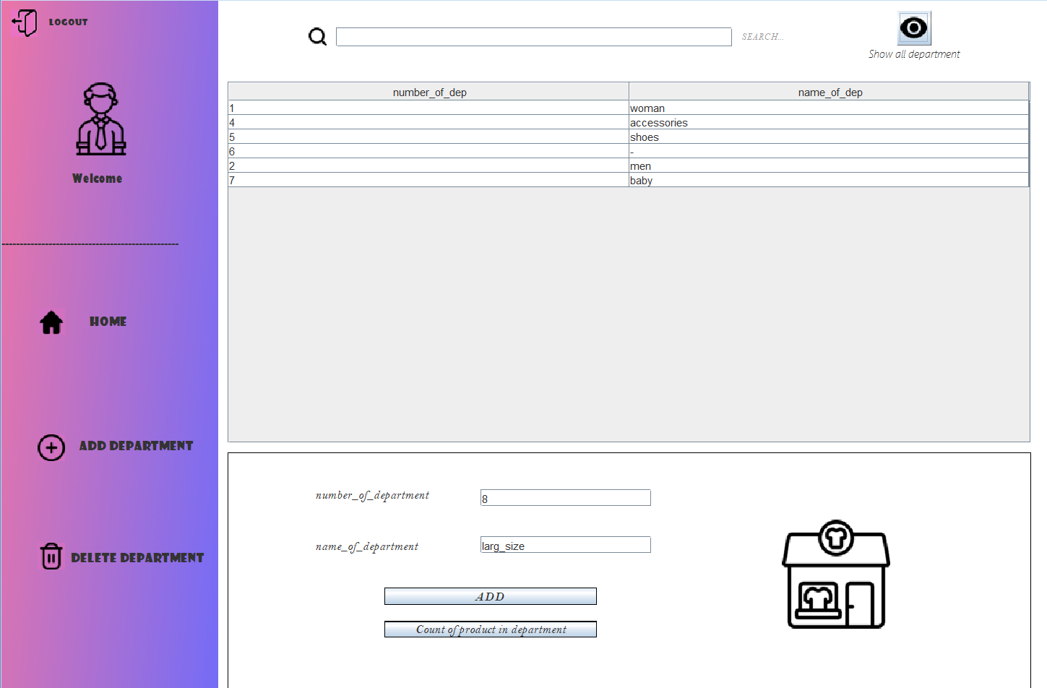

If I pressed on (Count of product on department) button it calculate the # of product based on name_of_department

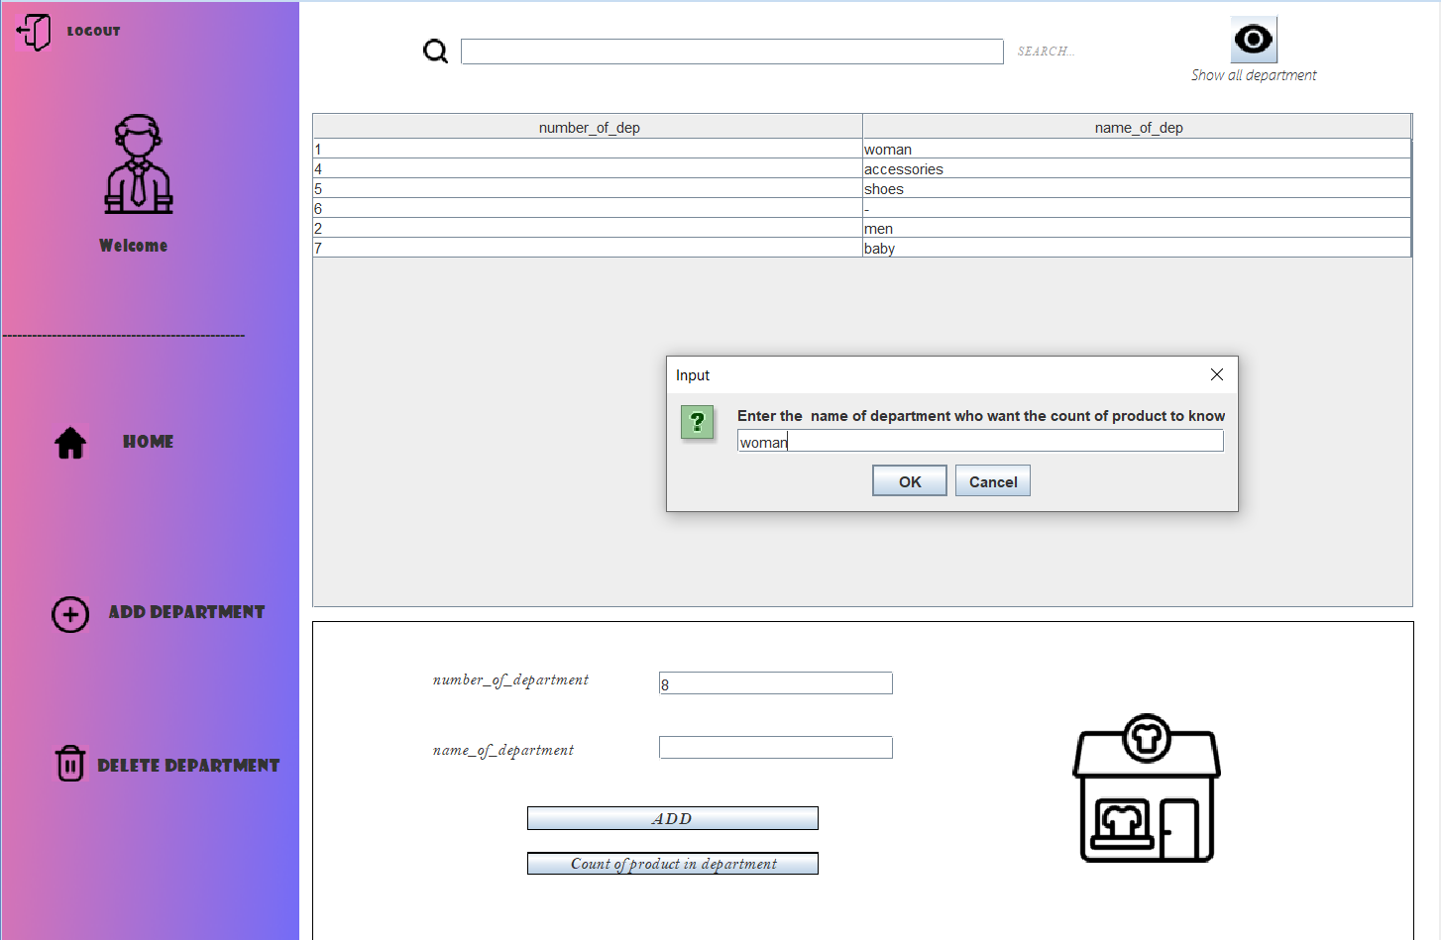

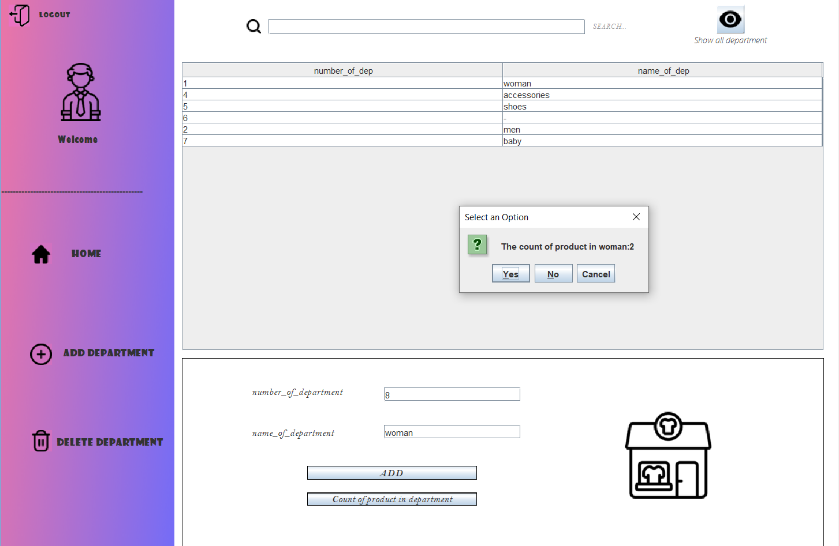



Note that if you enter name of department doesn’t add in the program it will not calculate there is ex.

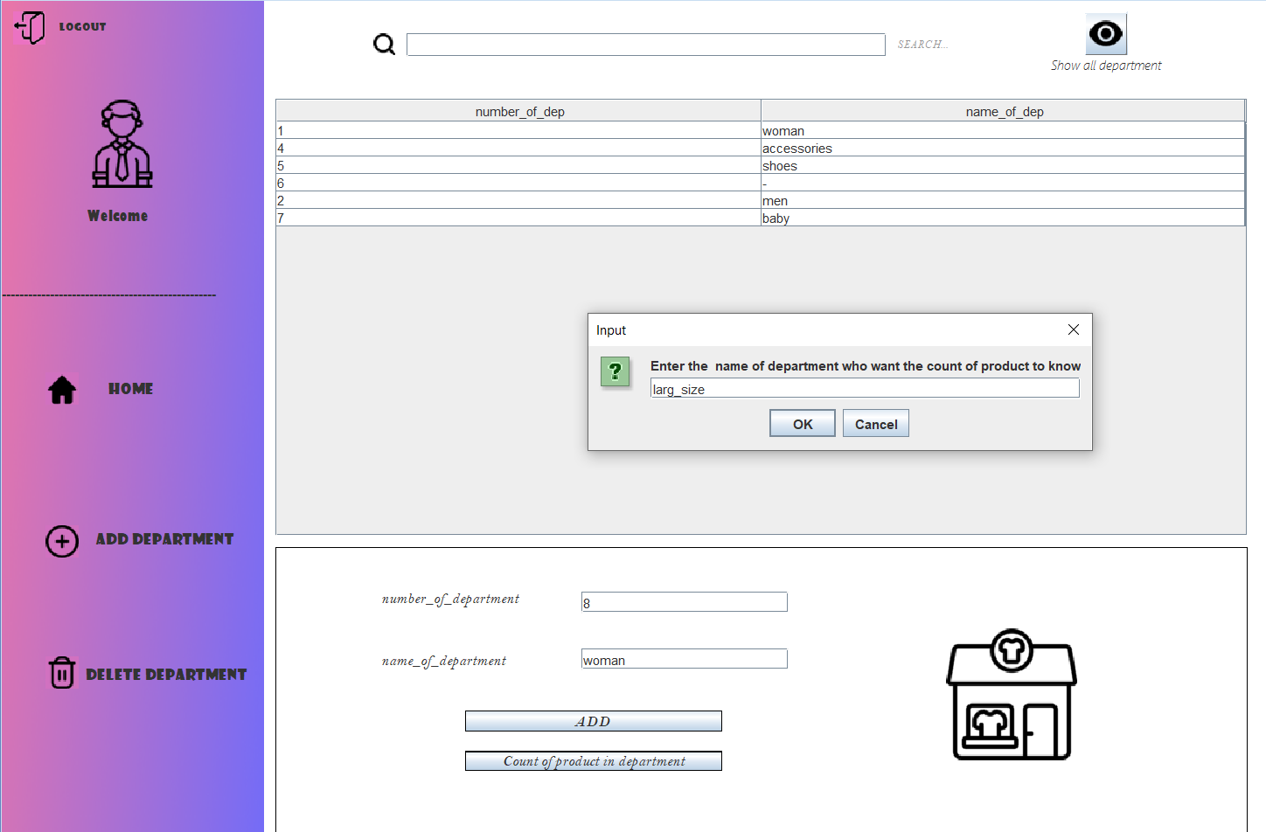

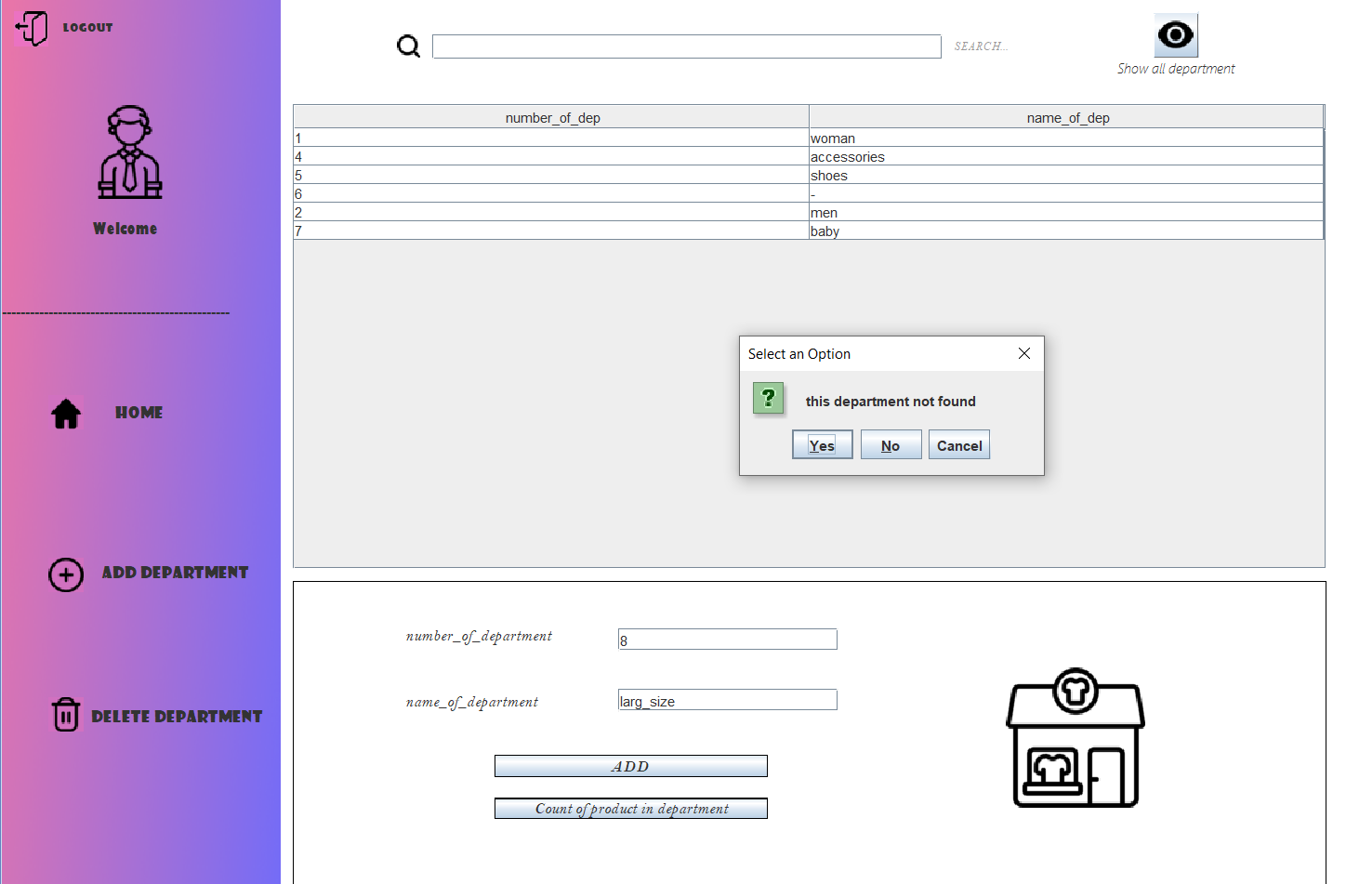

If I go back to home page then click on import 🡪 move to import page

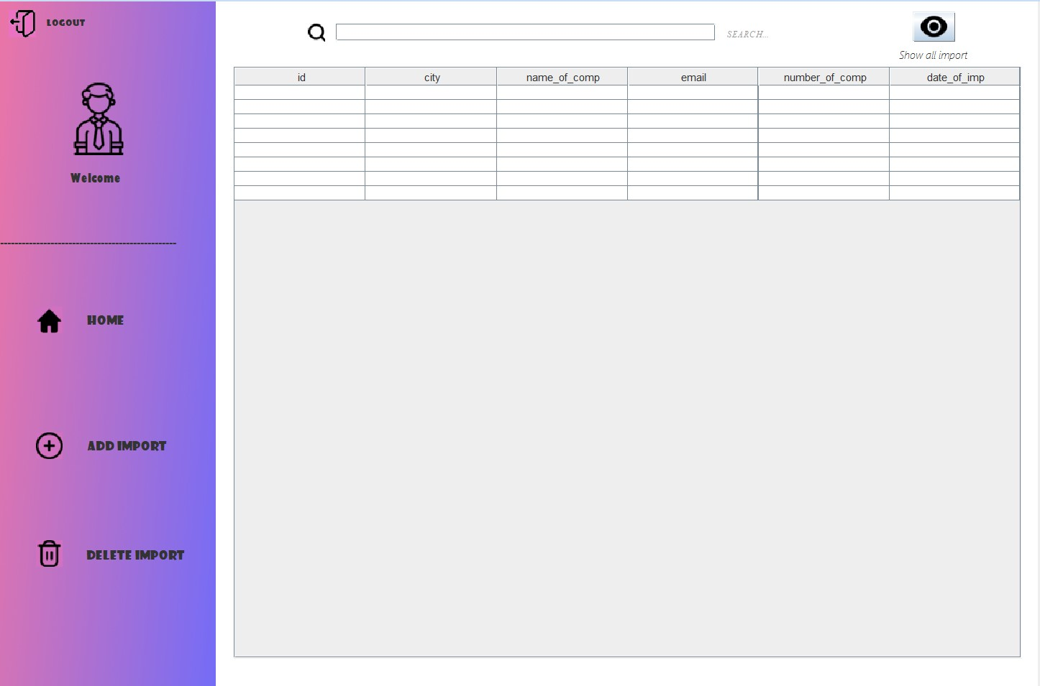

If click on Home button 🡪 go back to home page

If click on logout button 🡪 go back to login page

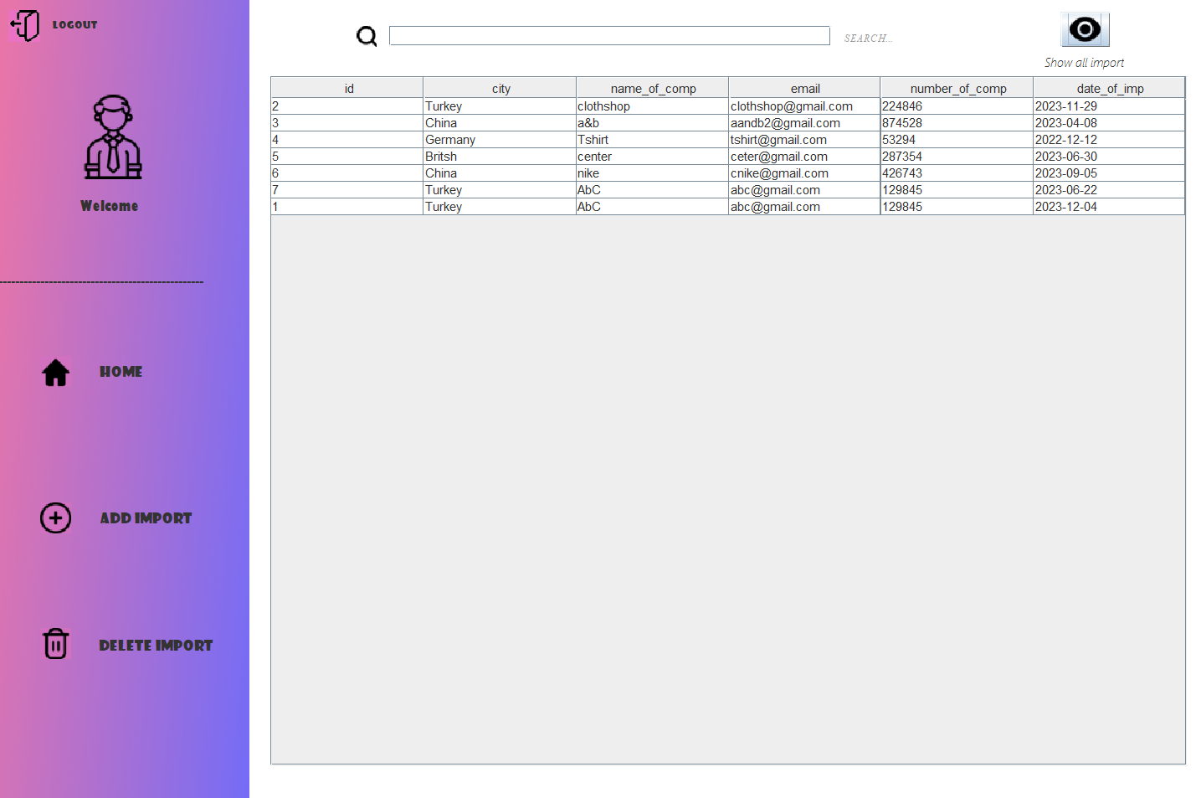If pressed on show all employee will appear:

You can also search about any company we imported from example:

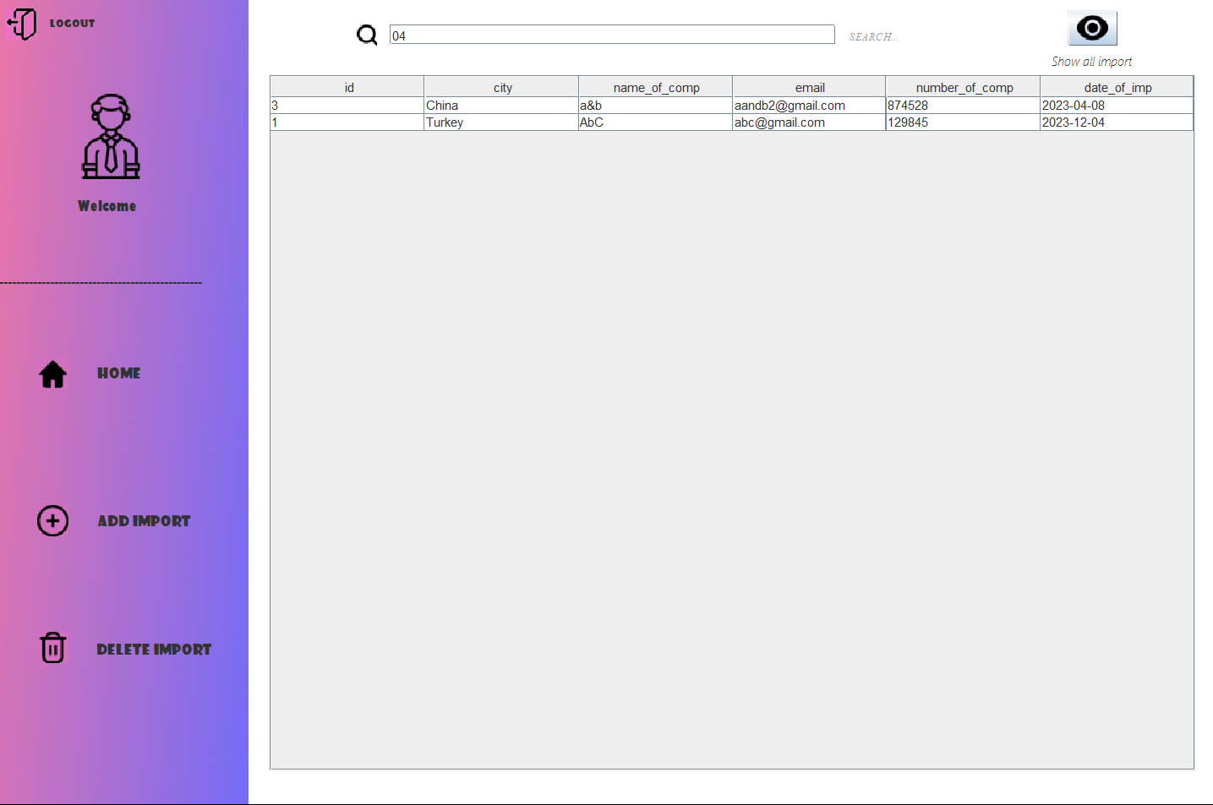

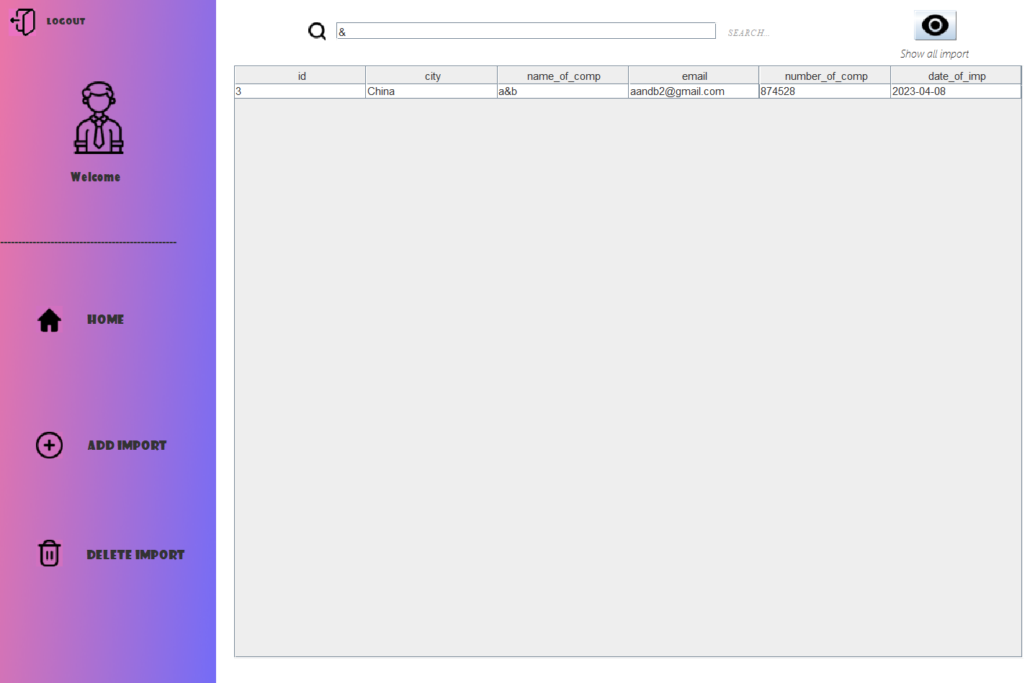

If pressed on then appear the panel to enter the new company:

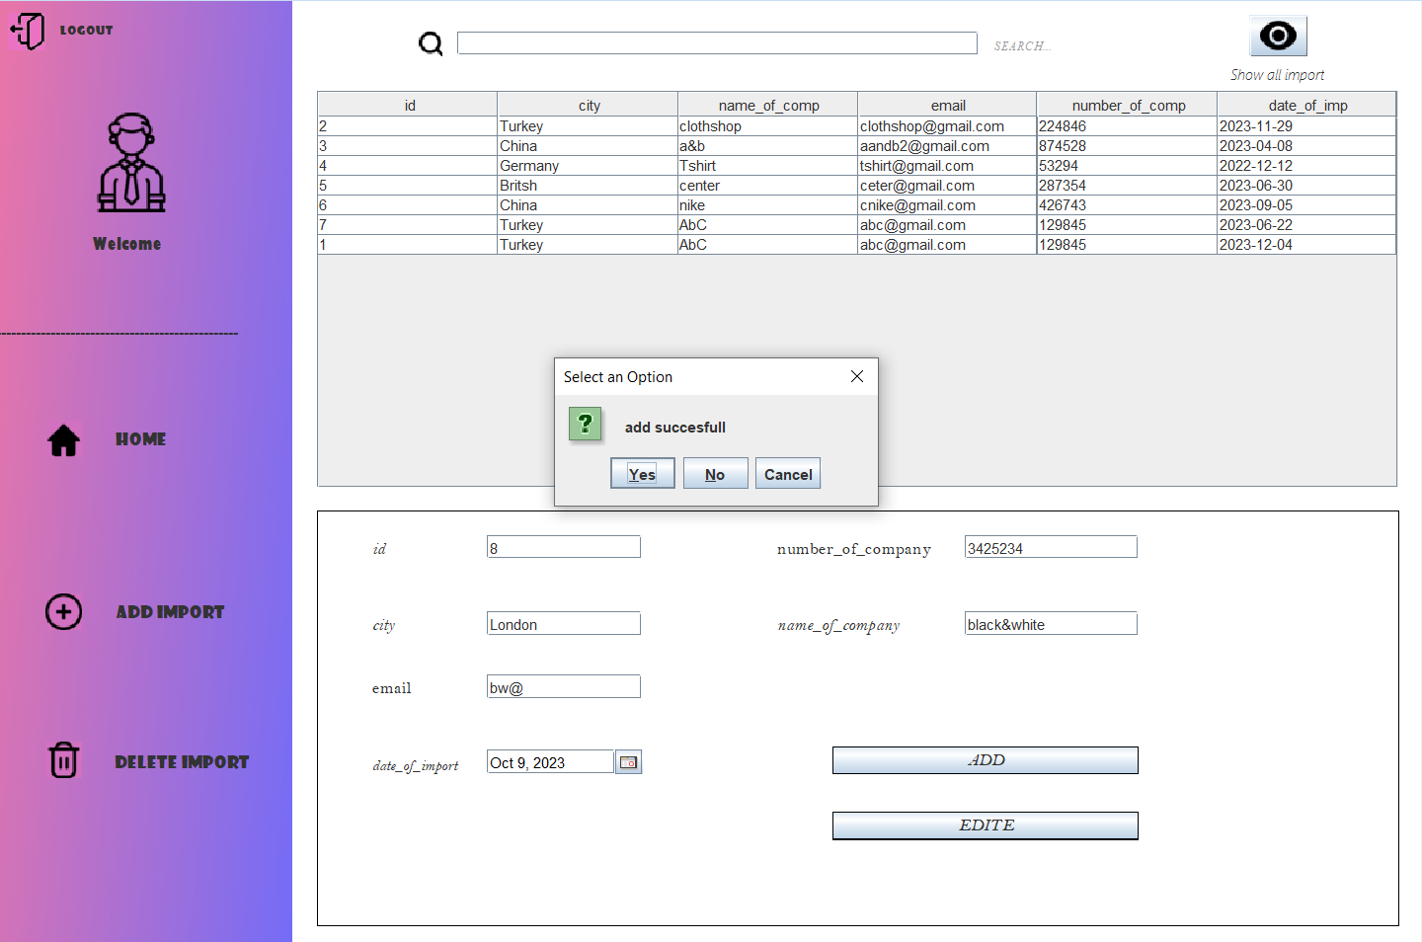

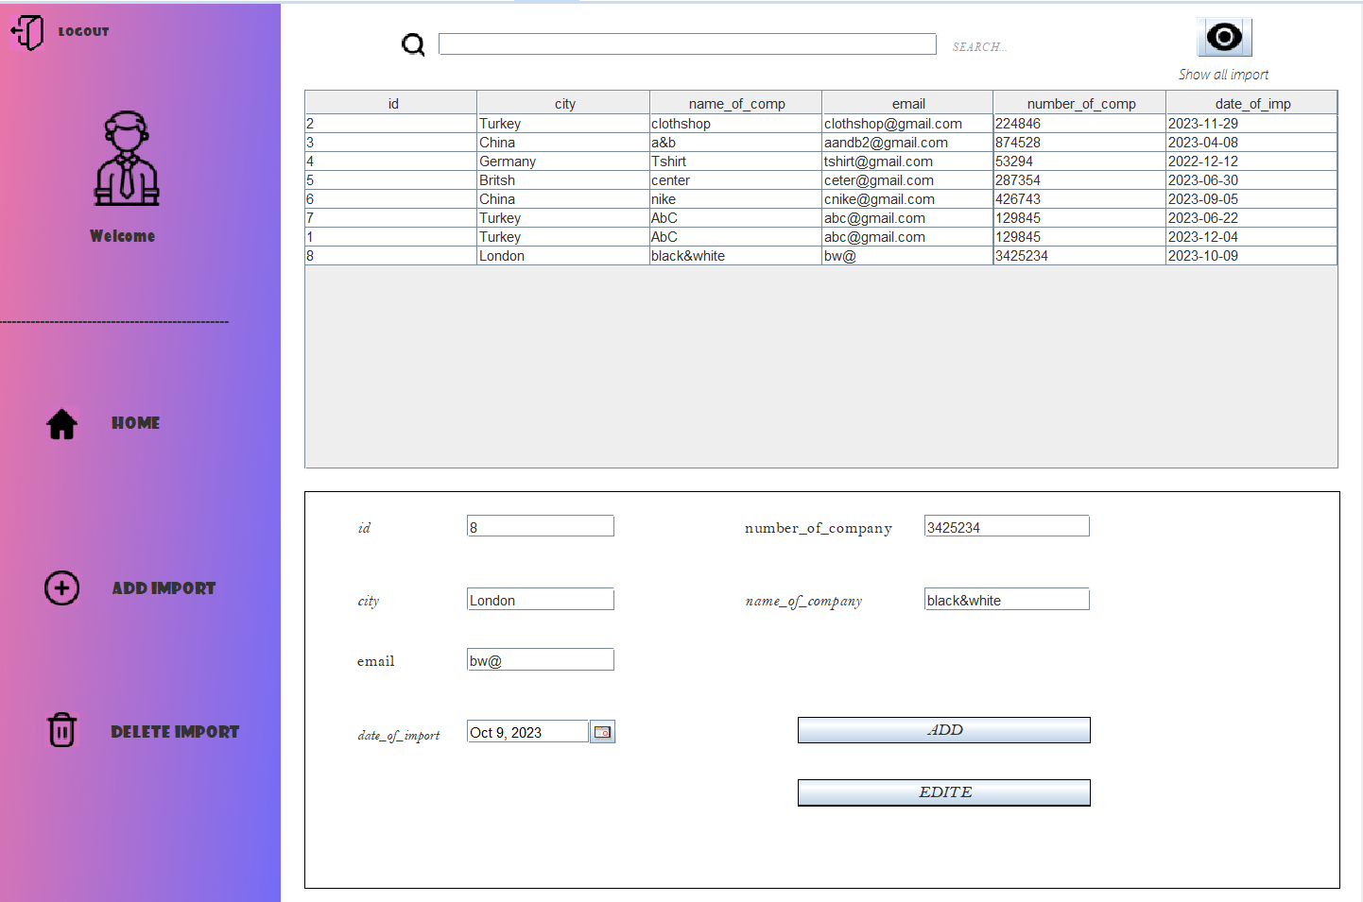

If I pressed on then you can remove any company based on id there’s ex.

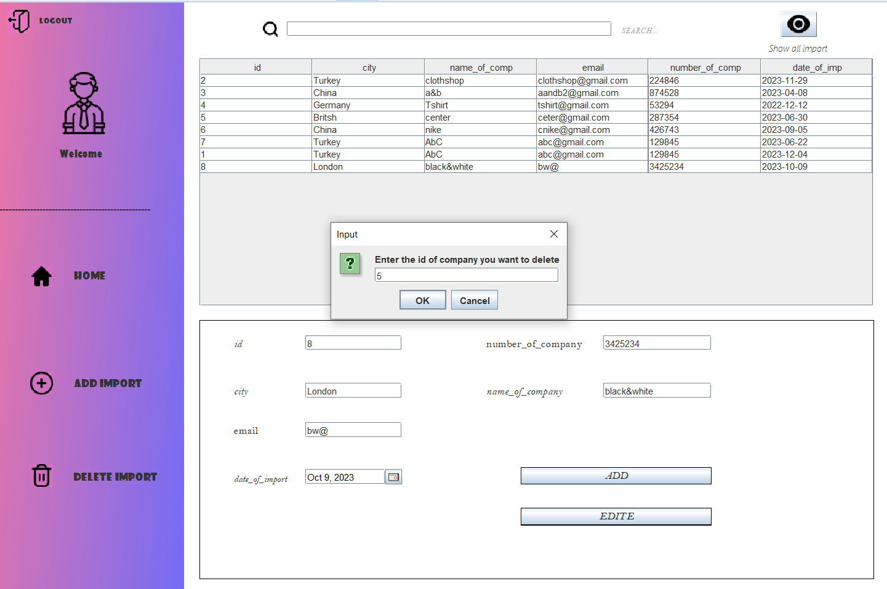

The result

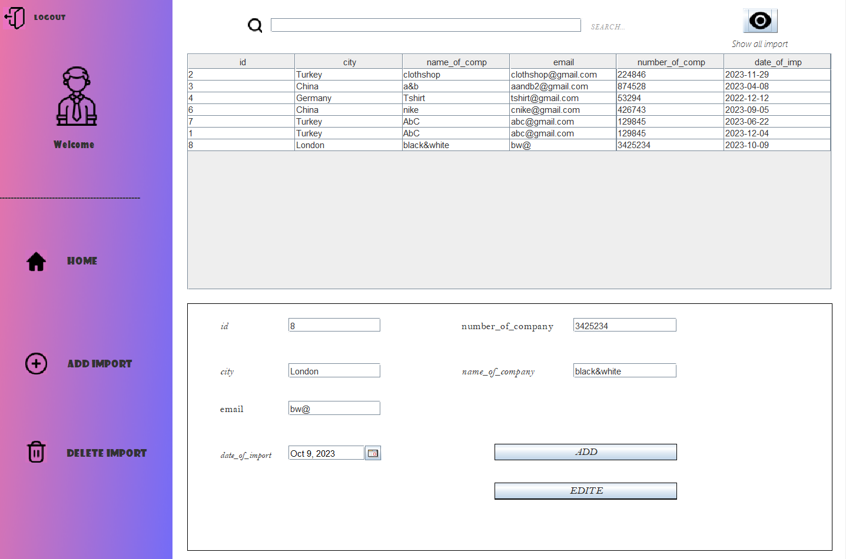

If I click in (Edite) button I can update the date of import based on id

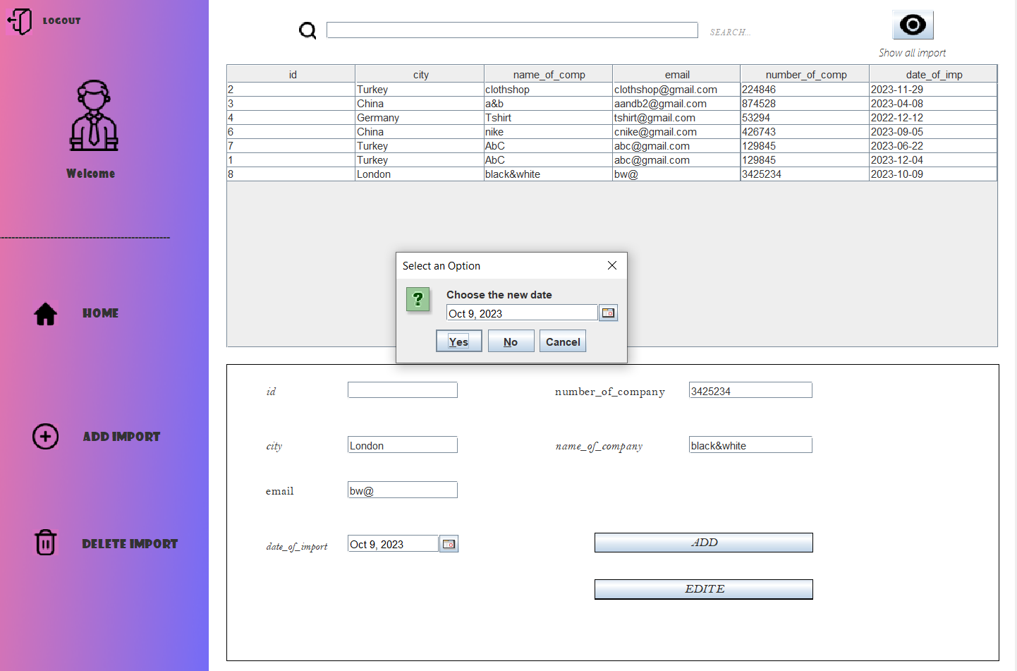

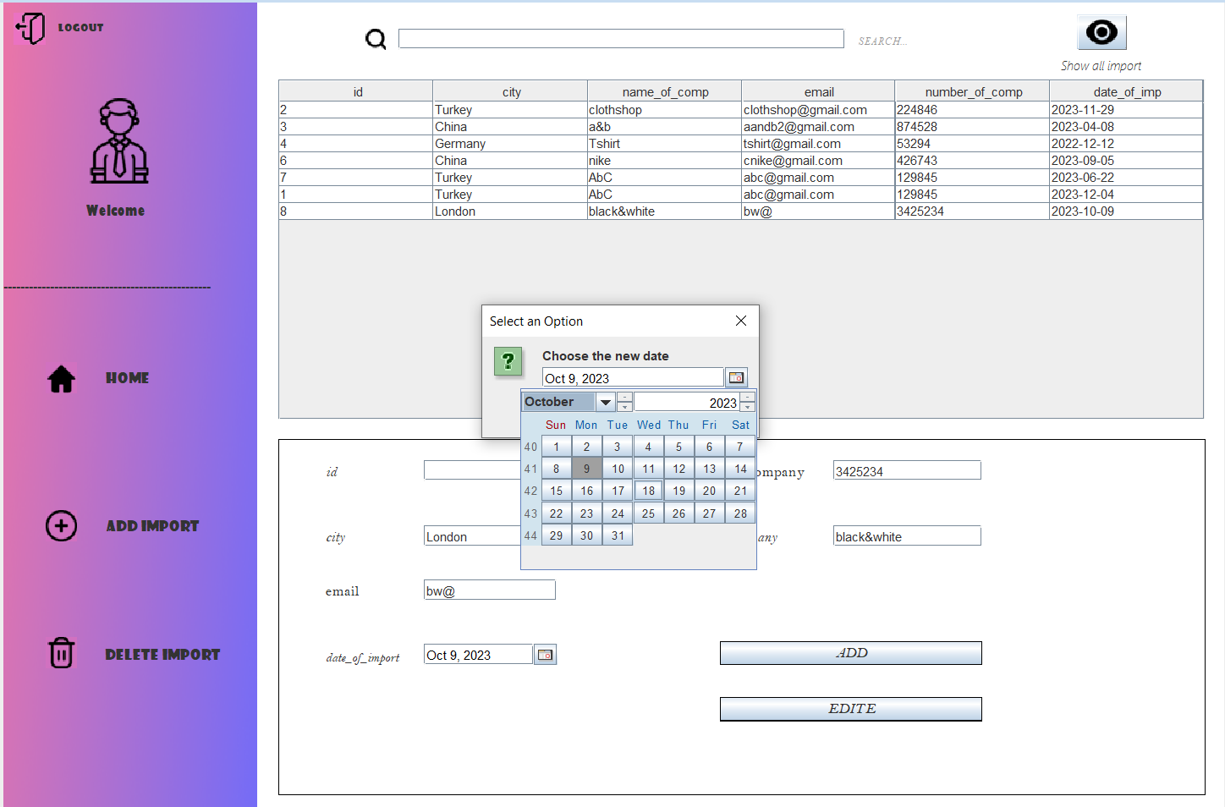

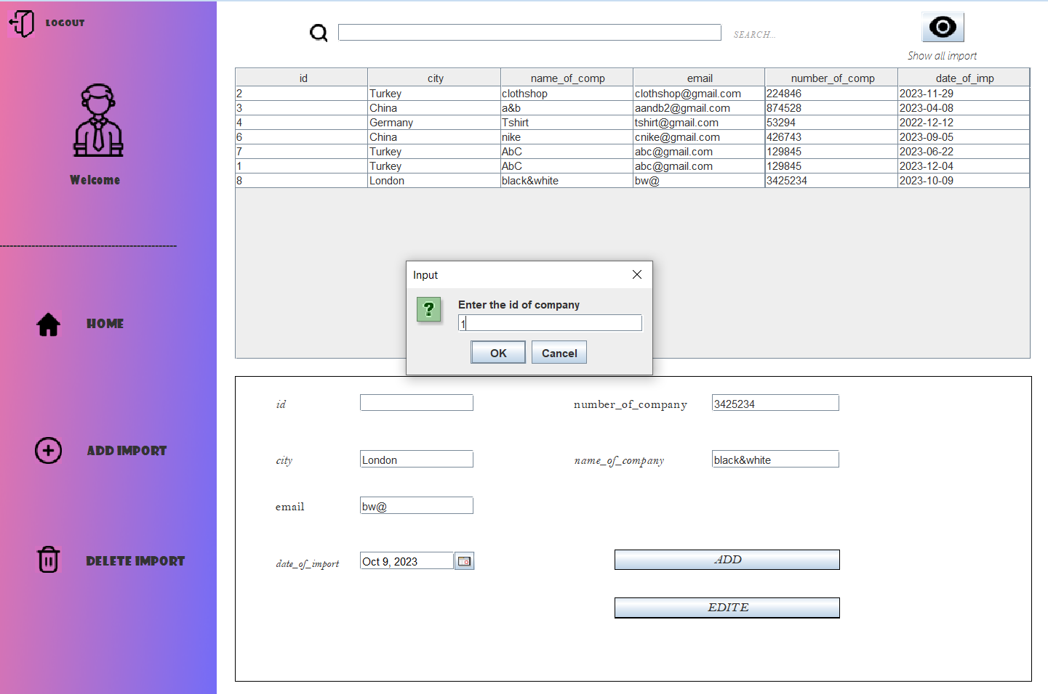

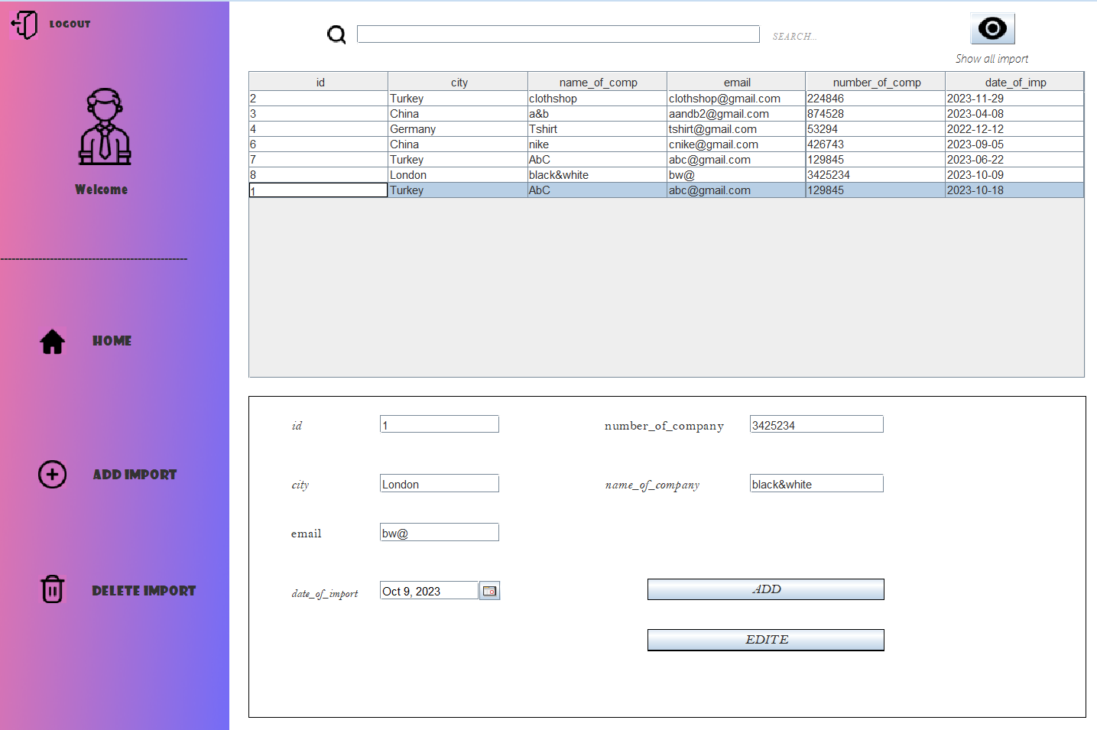



If I back to home page and pressed on branch will move to branch page

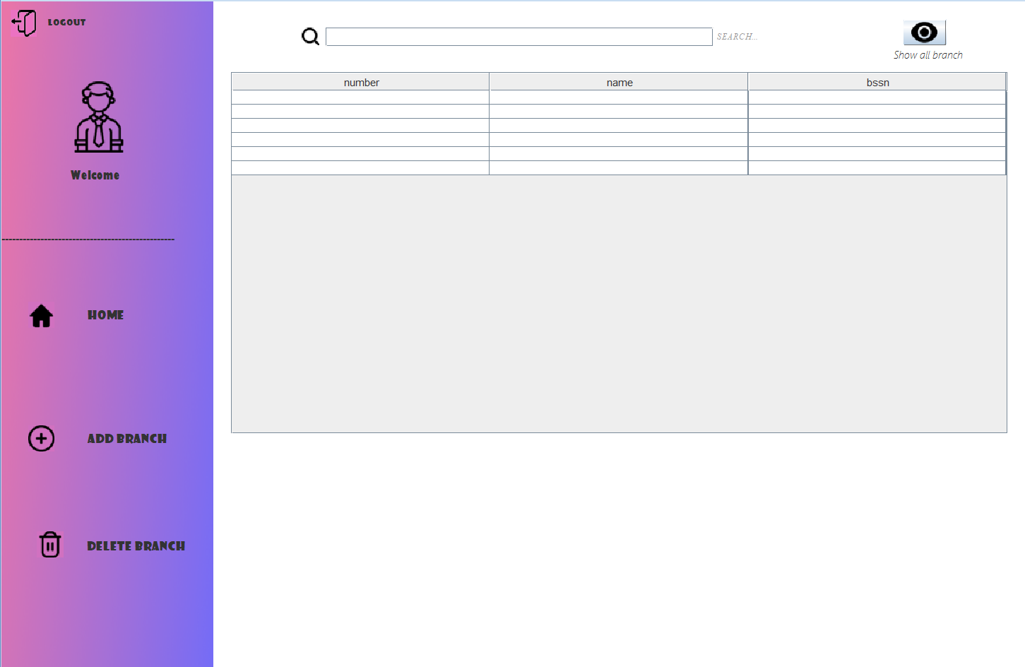



If click on Home button 🡪 go back to home page

If click on logout button 🡪 go back to login page

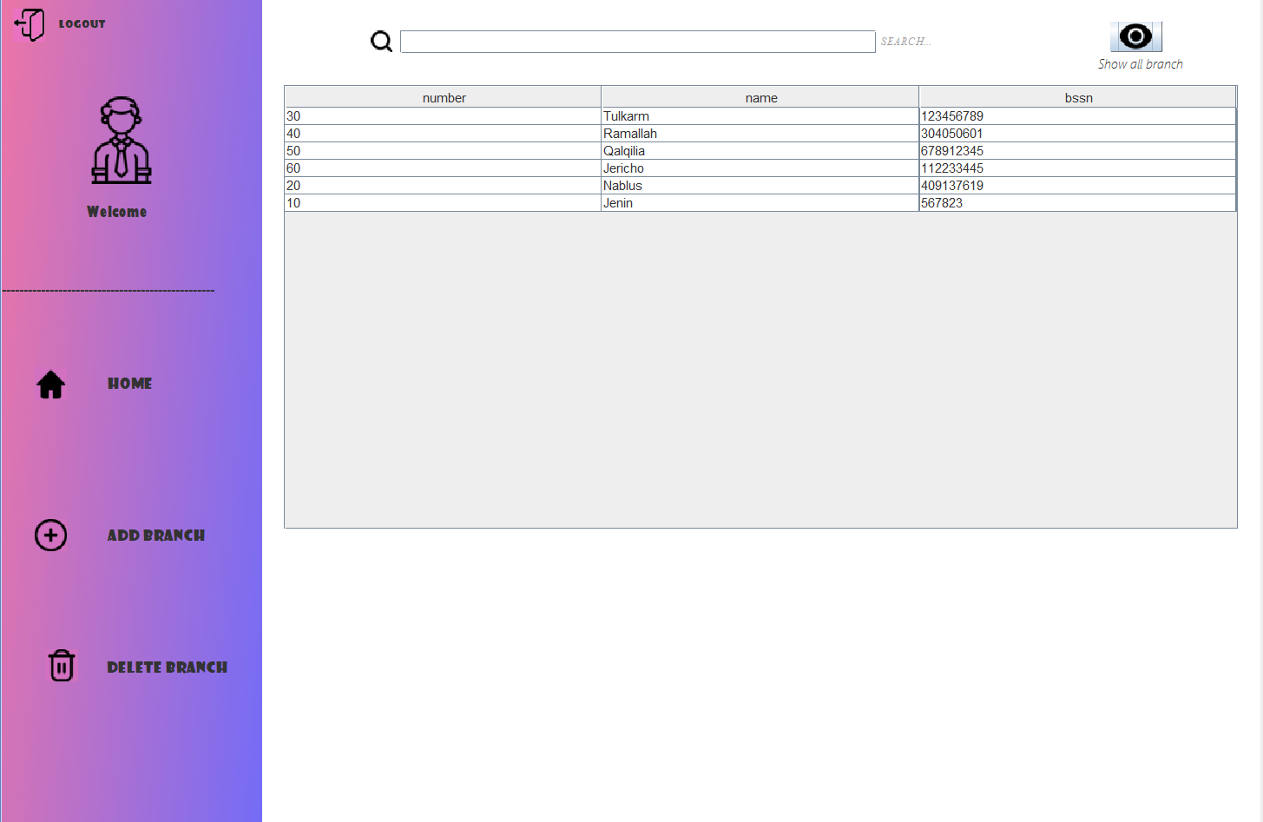If pressed on show all employee will appear:

You can also search about any branch from example:

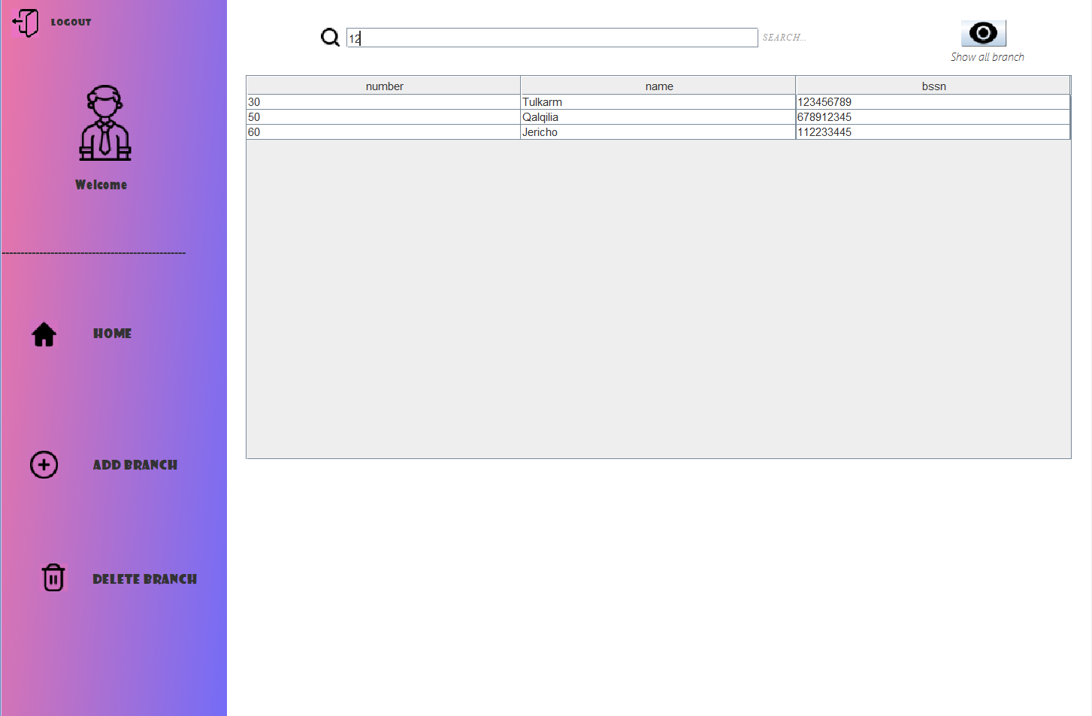

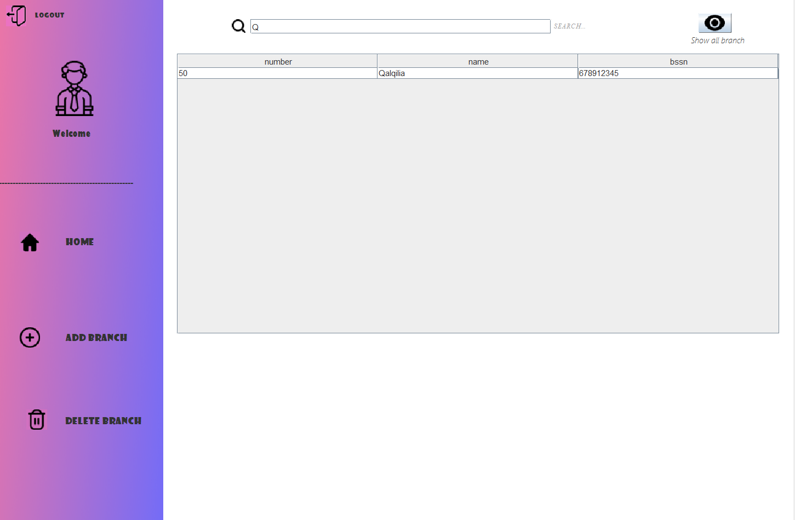

If pressed on then appear the panel to enter the new branch:

Know that you can’t add new branch & the manager not add also.

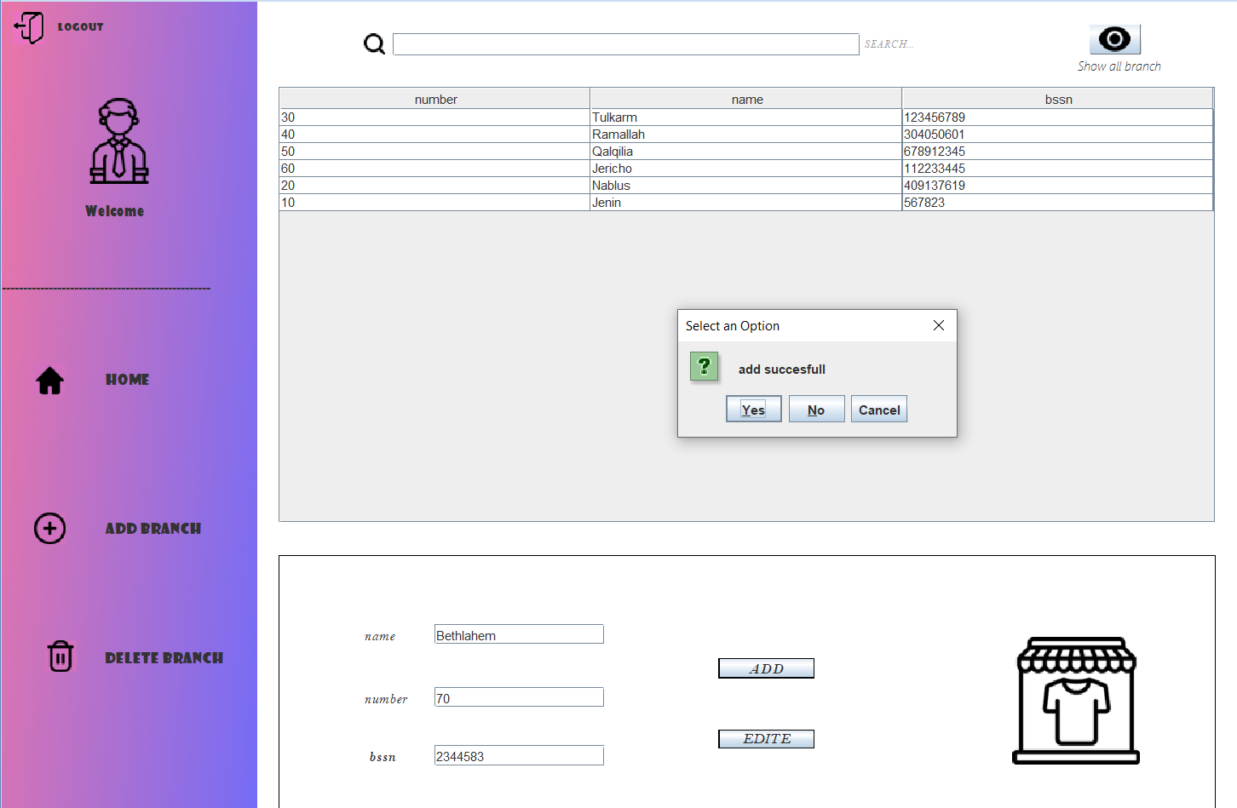

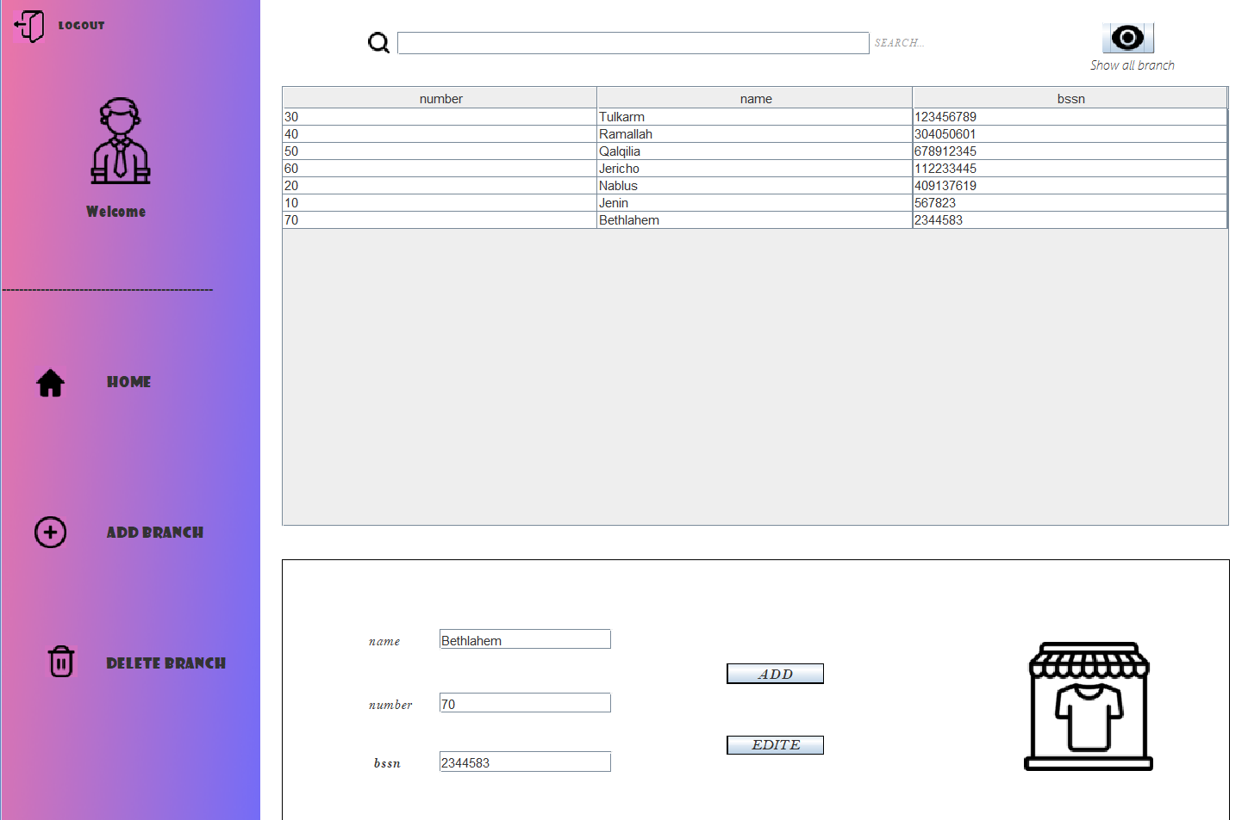



If I pressed on then you can remove any branch based on number there’s ex.

When you delete branch then every employee in this branch will delete

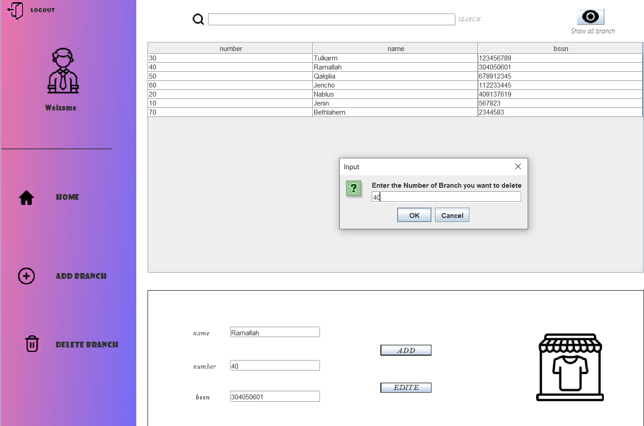



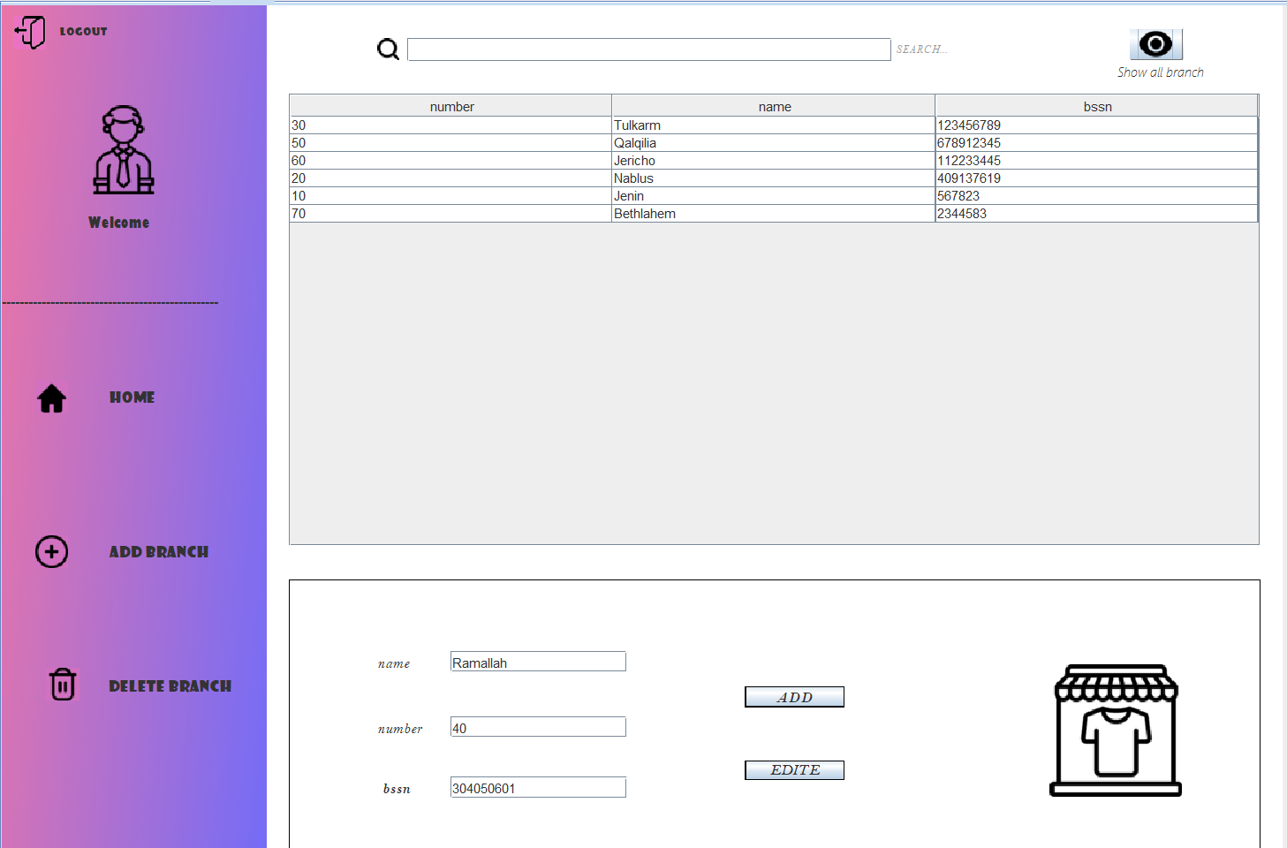

Before delete Ramallah

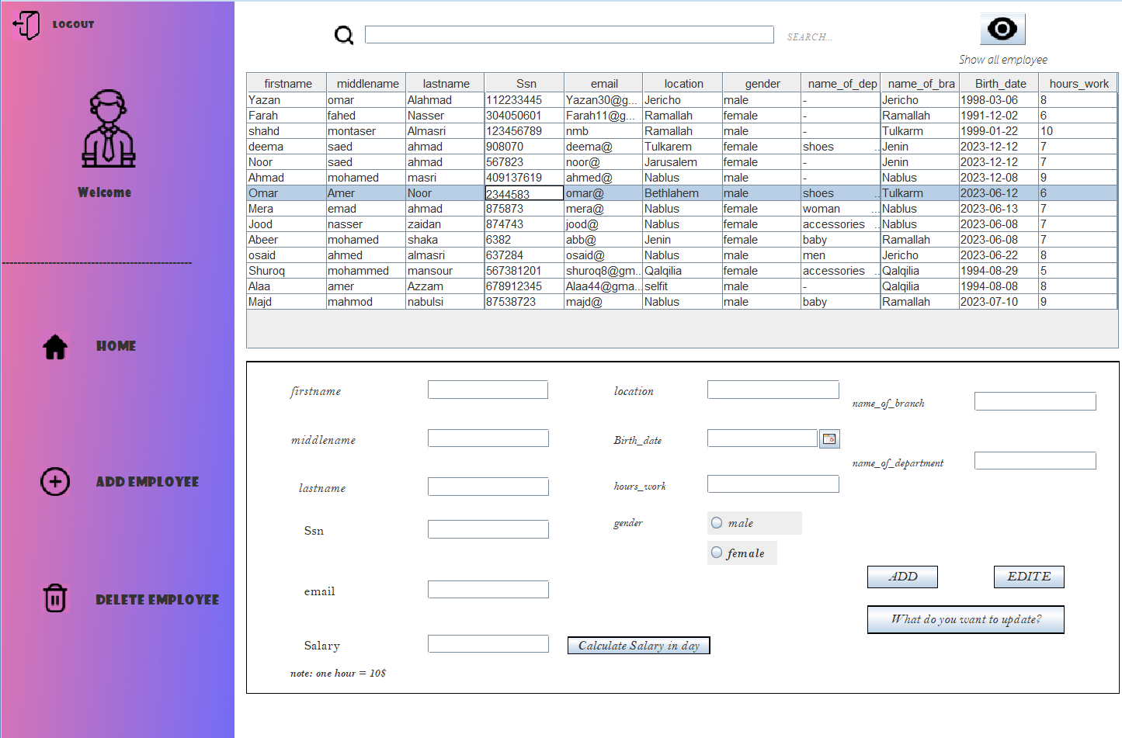

After delete

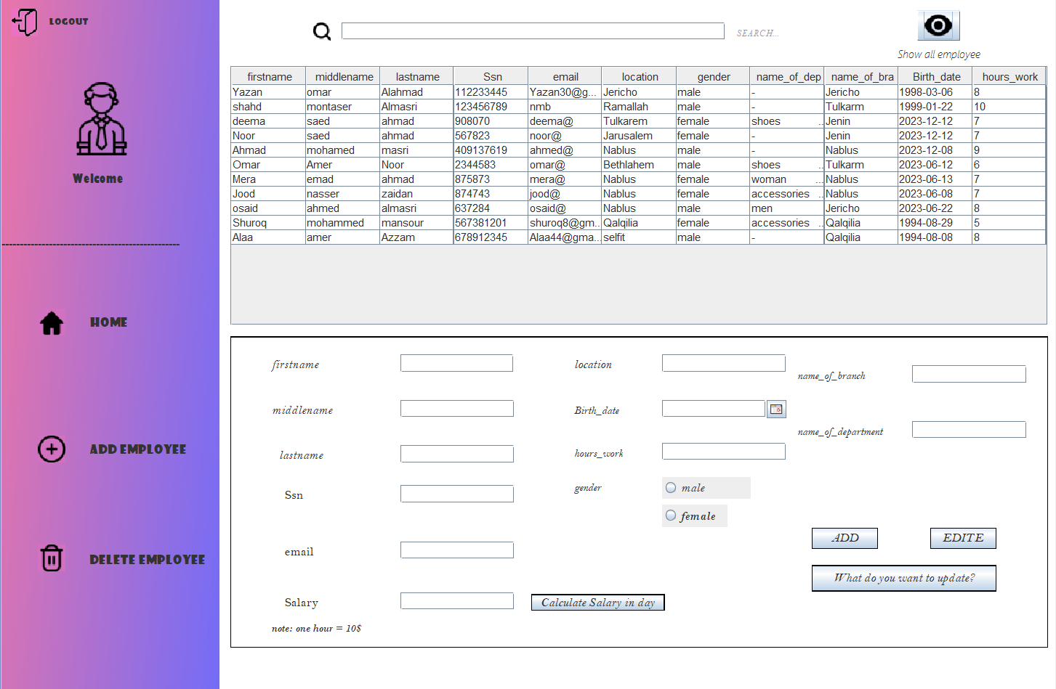

If I pressed on (Edite) button I can update the manger of branch based on Ssn

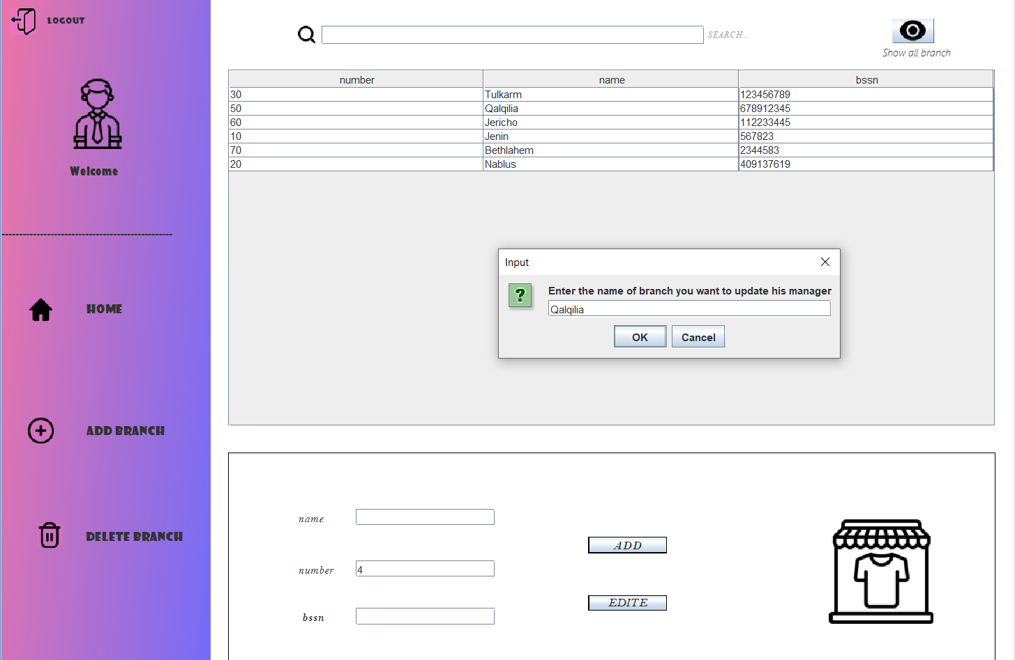

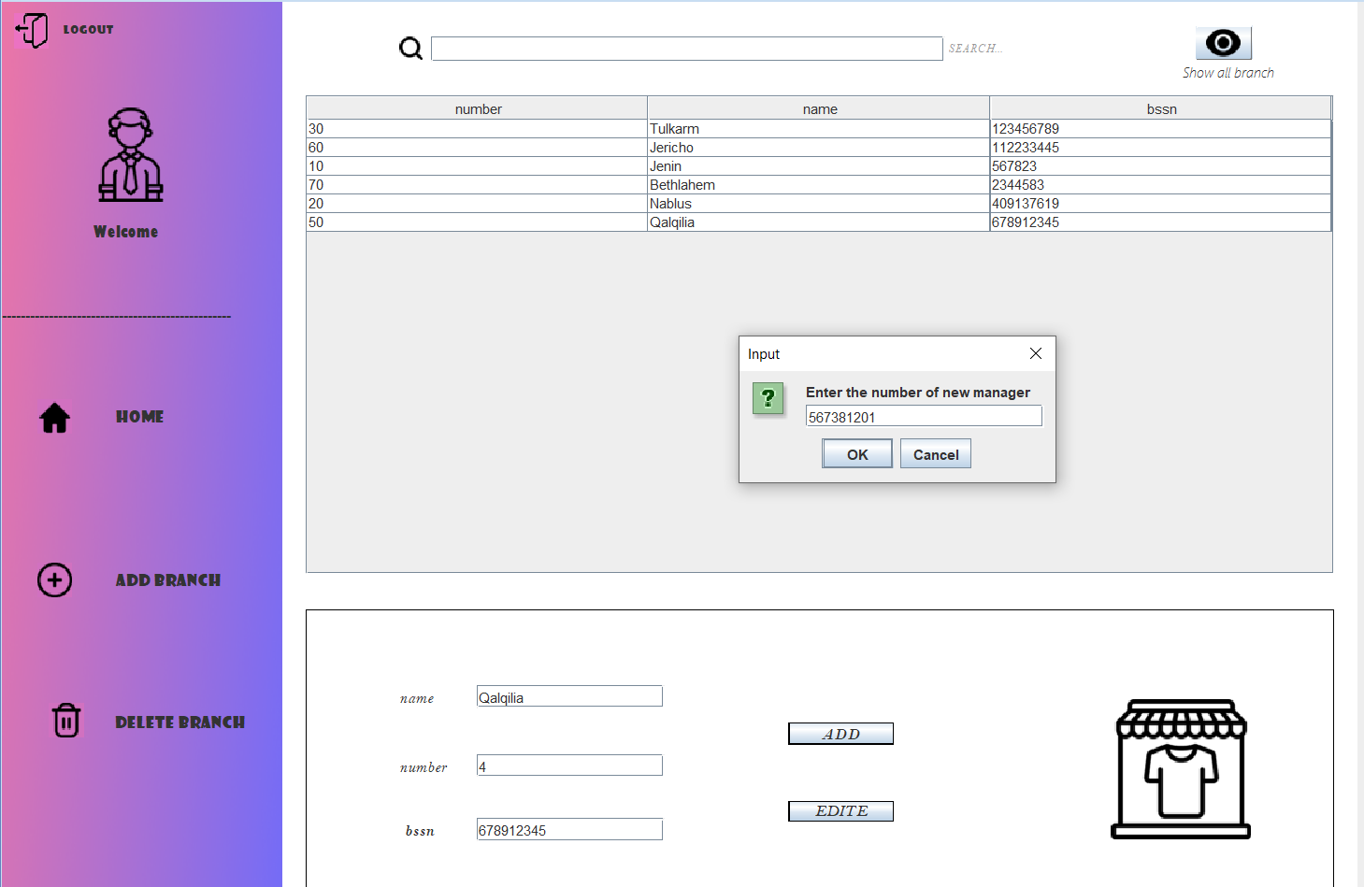

The result

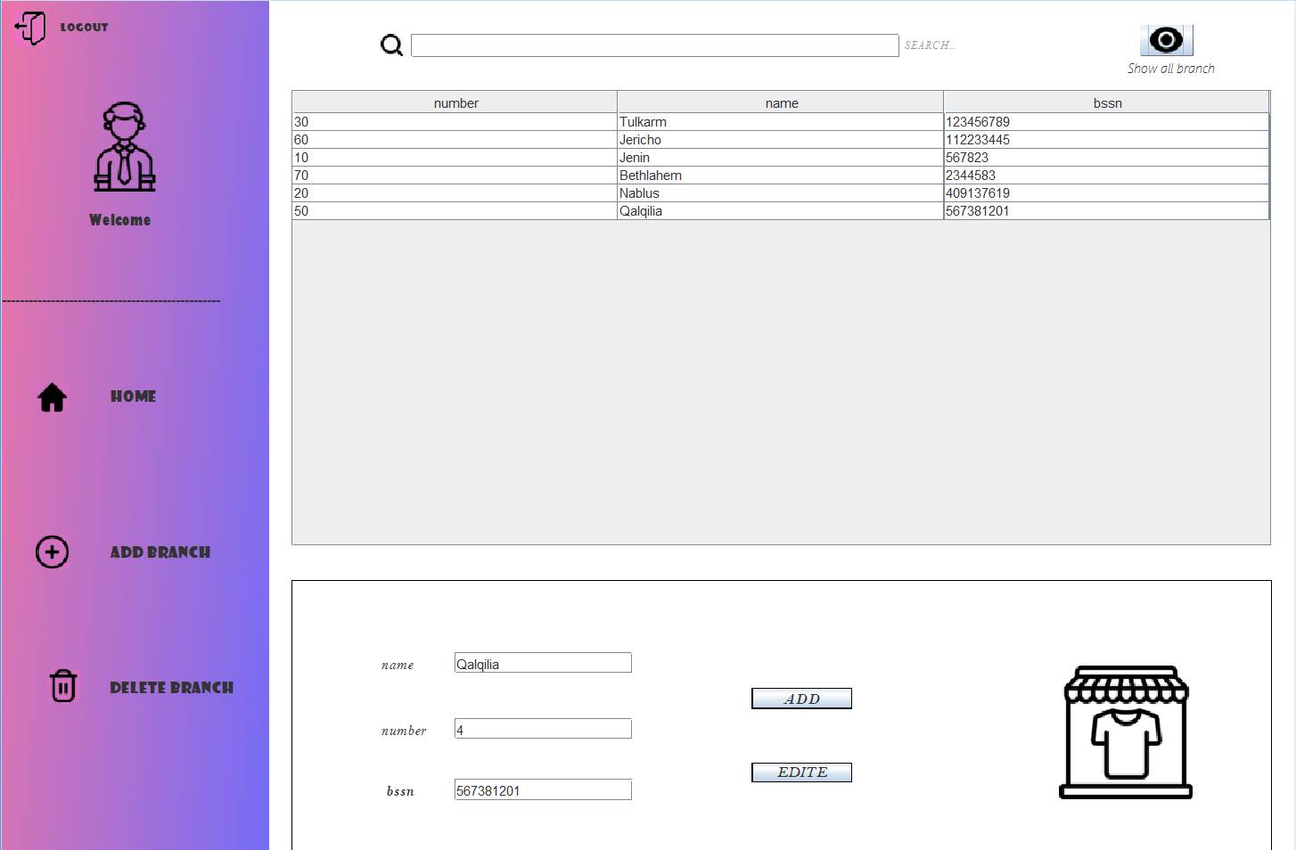

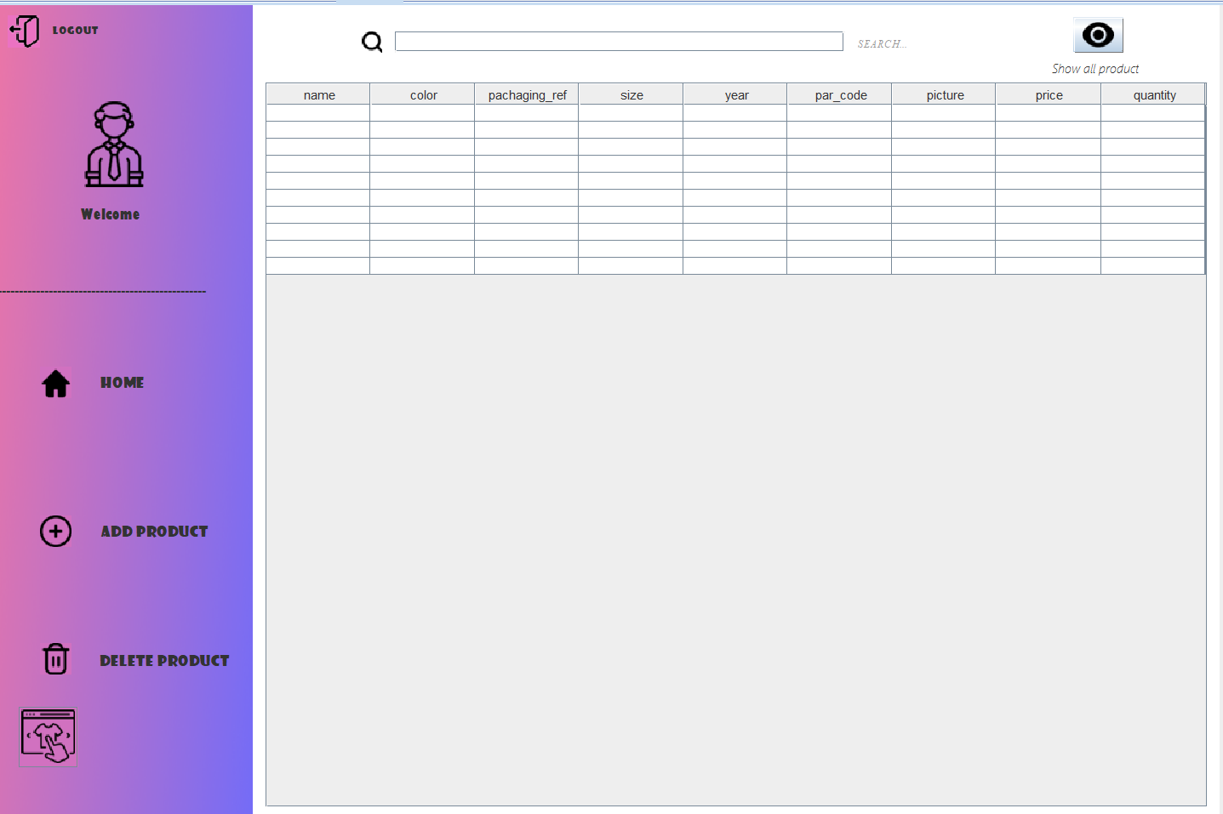If I back to home page and pressed on product will move to product page



If click on Home button 🡪 go back to home page

If click on logout button 🡪 go back to login page

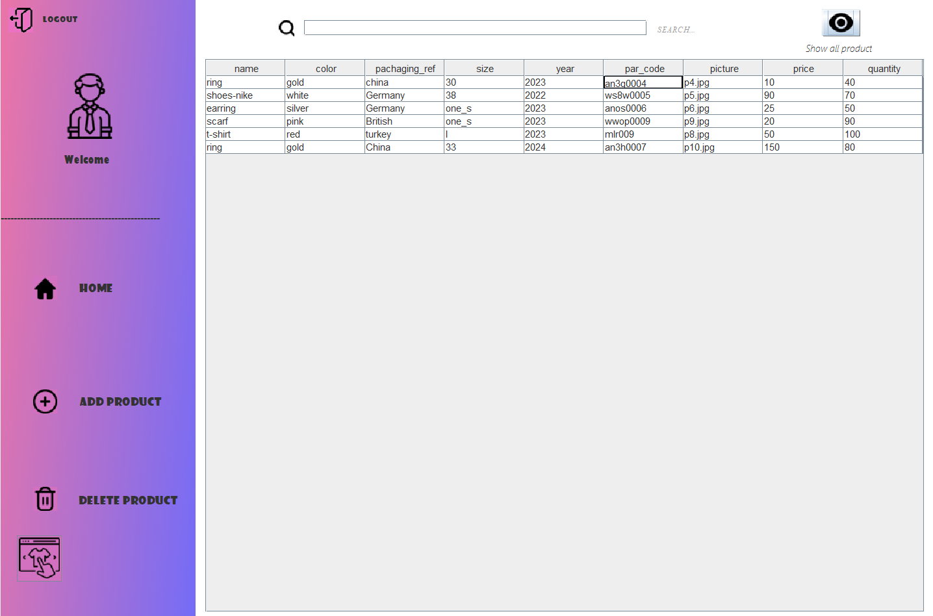If pressed on show all employee will appear:

You can also search about any product from example:

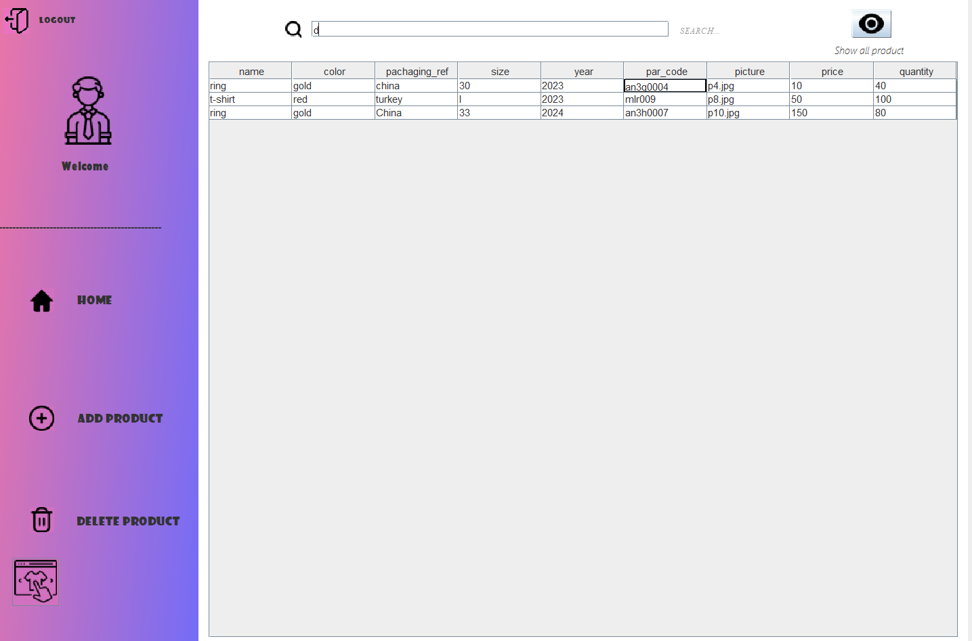

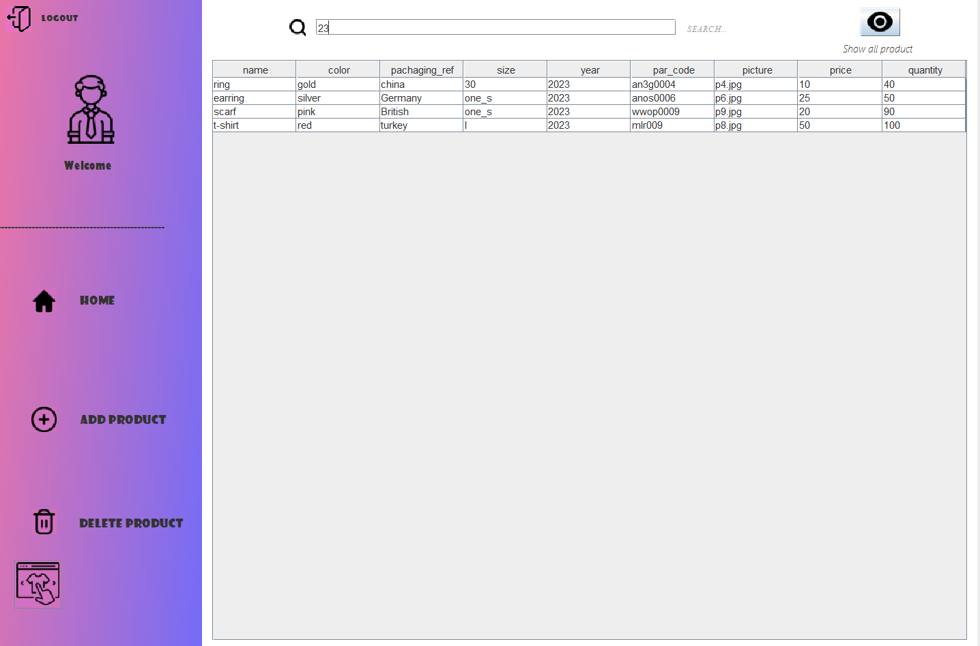

If pressed on then appear the panel to enter the new product:

Ex. “name of department & id to connect with imported & contains table”

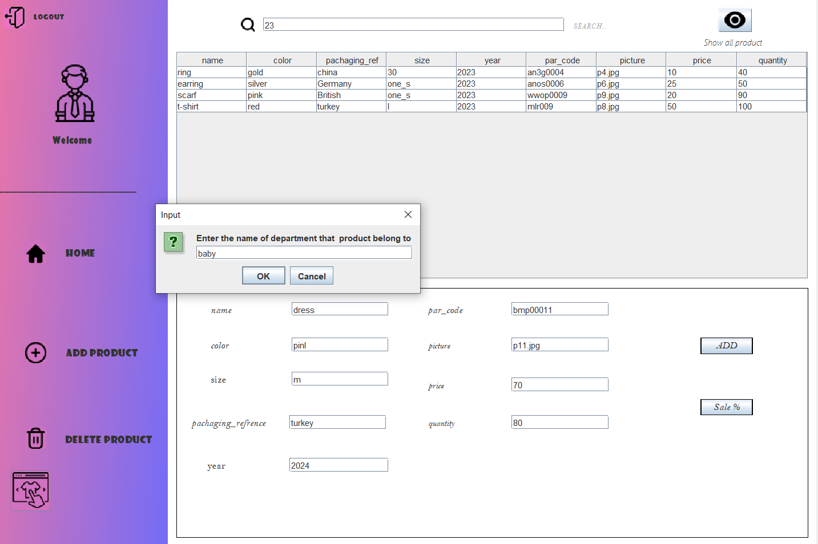

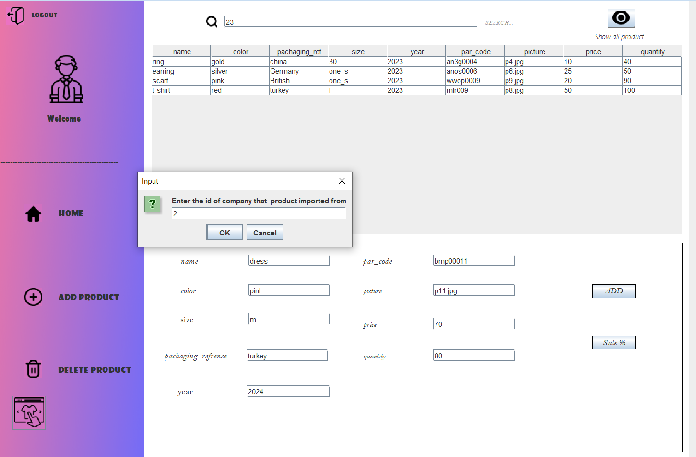

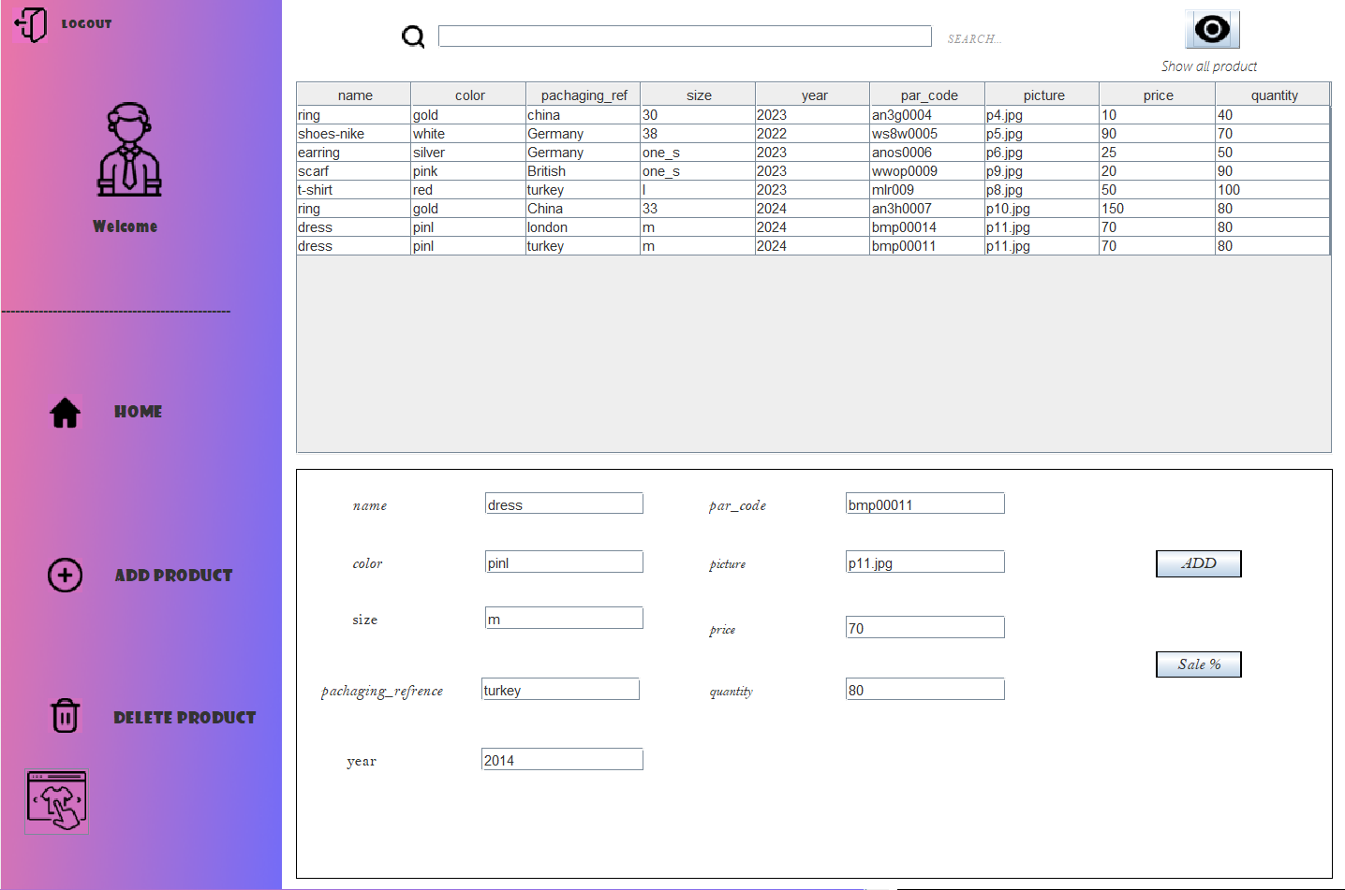

I can’t added to department or company I’m not added.

If I pressed on then you can remove any product based on par_code there’s ex.

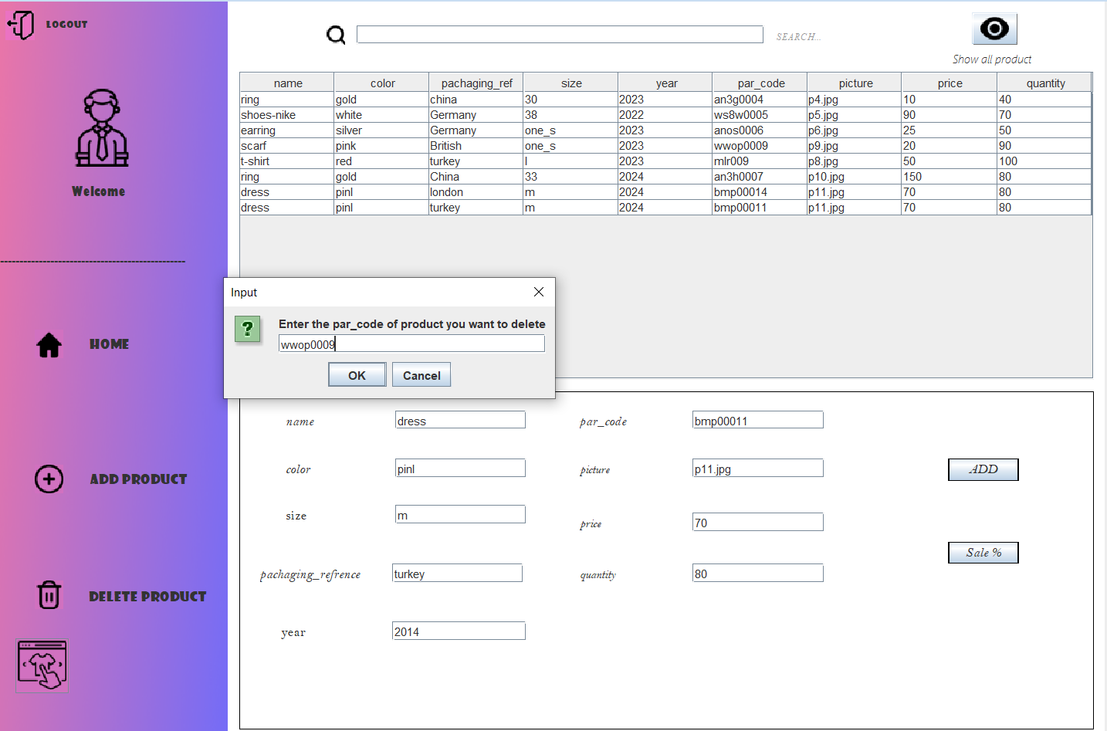

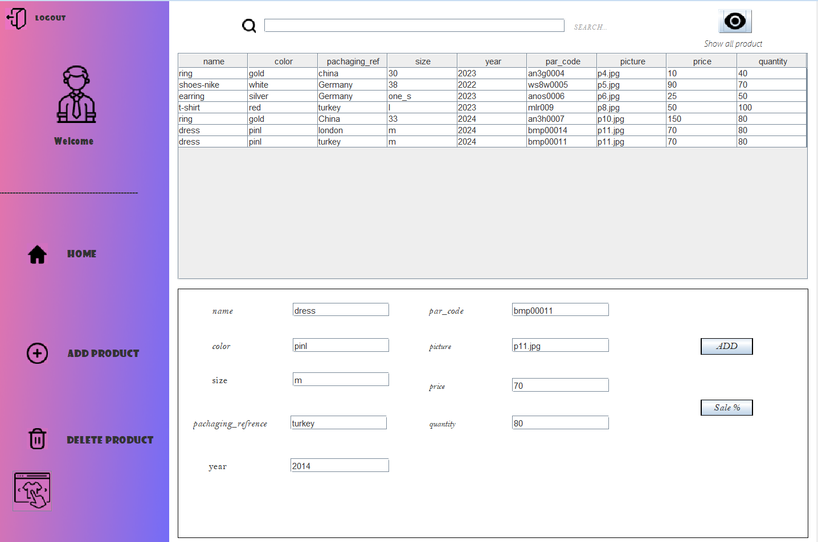

If I pressed on (Sale %) button I will update the price of product based on par_code

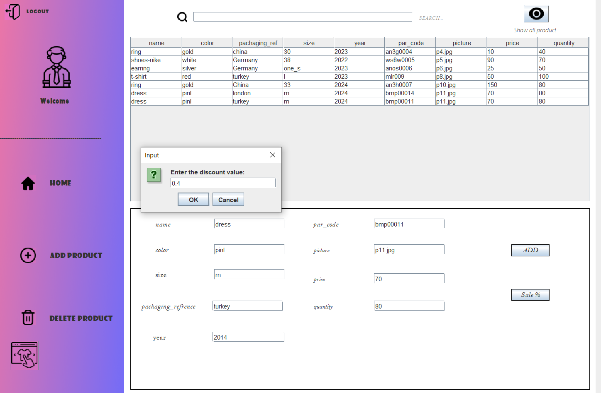

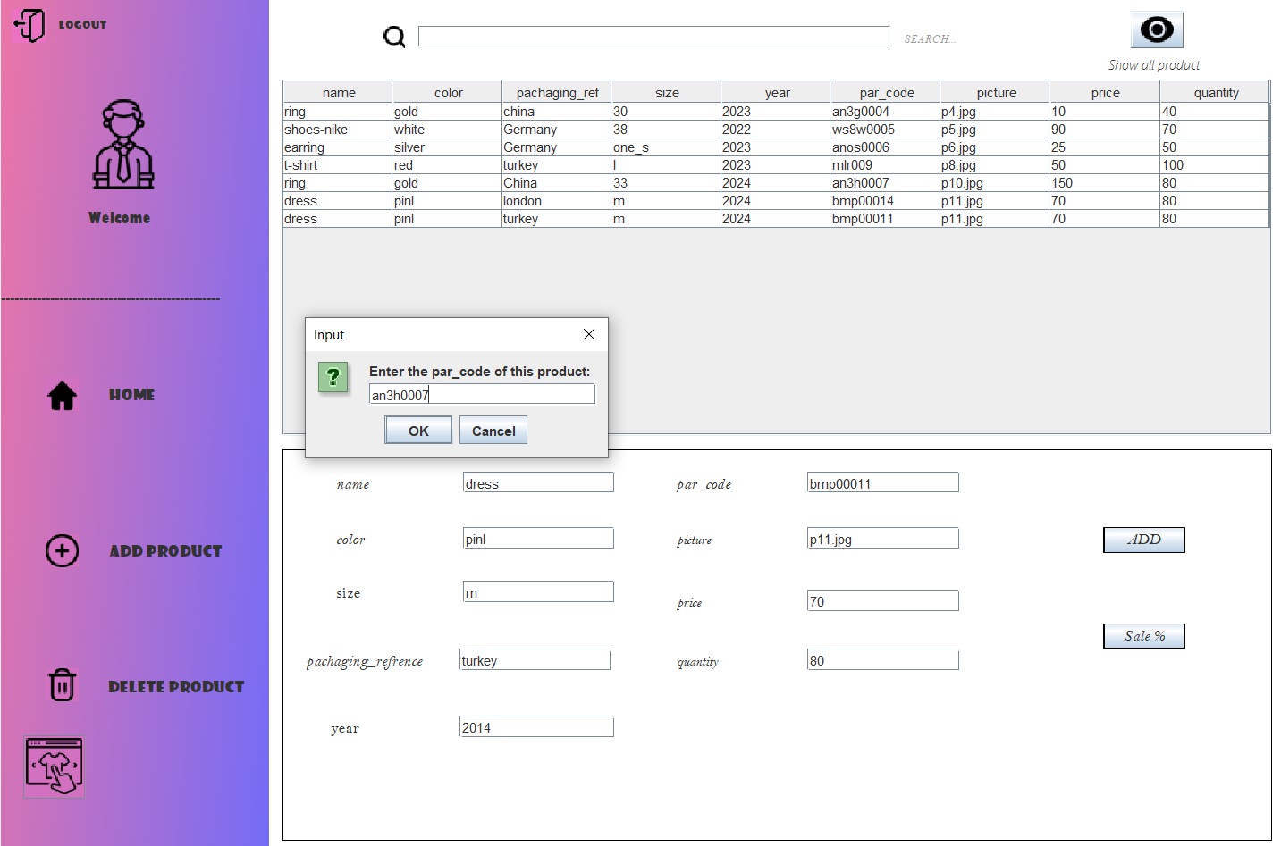

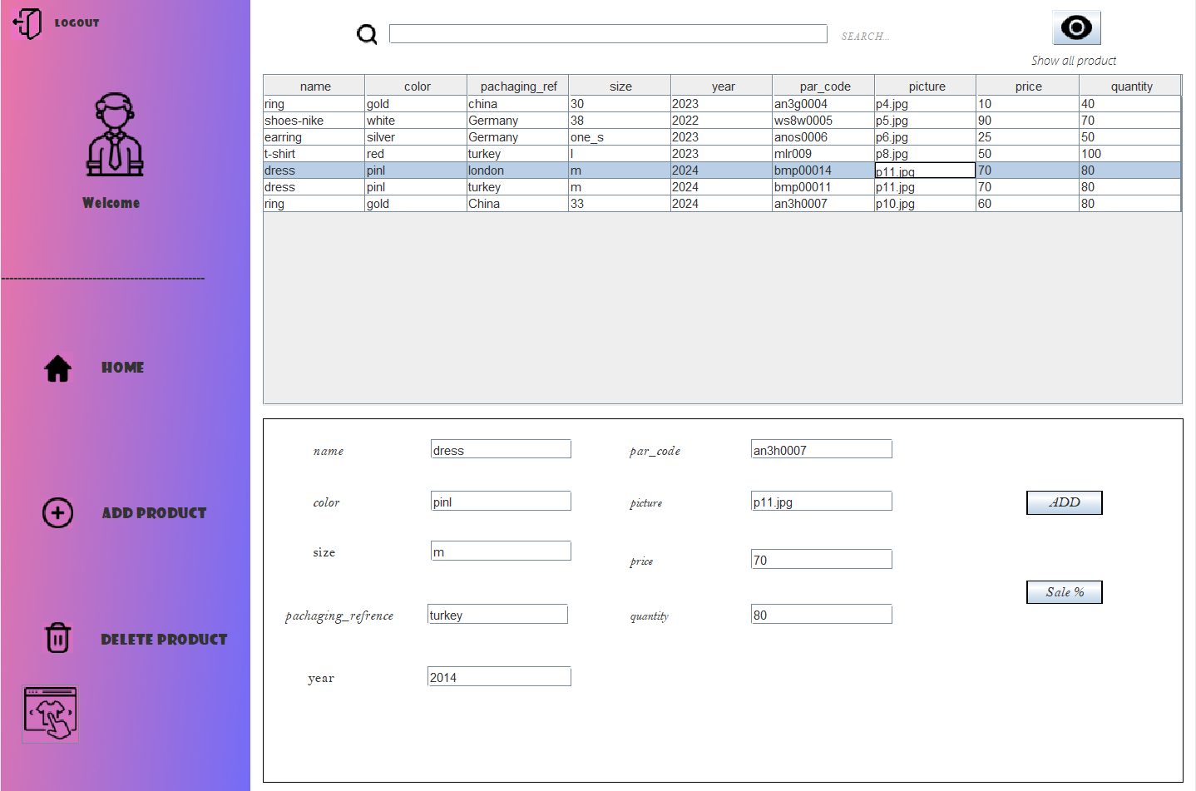

If I click on the I move to frame to choose any department I want to show its product

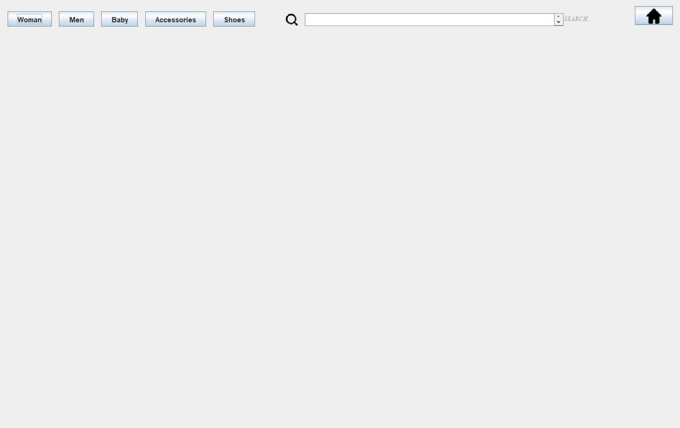

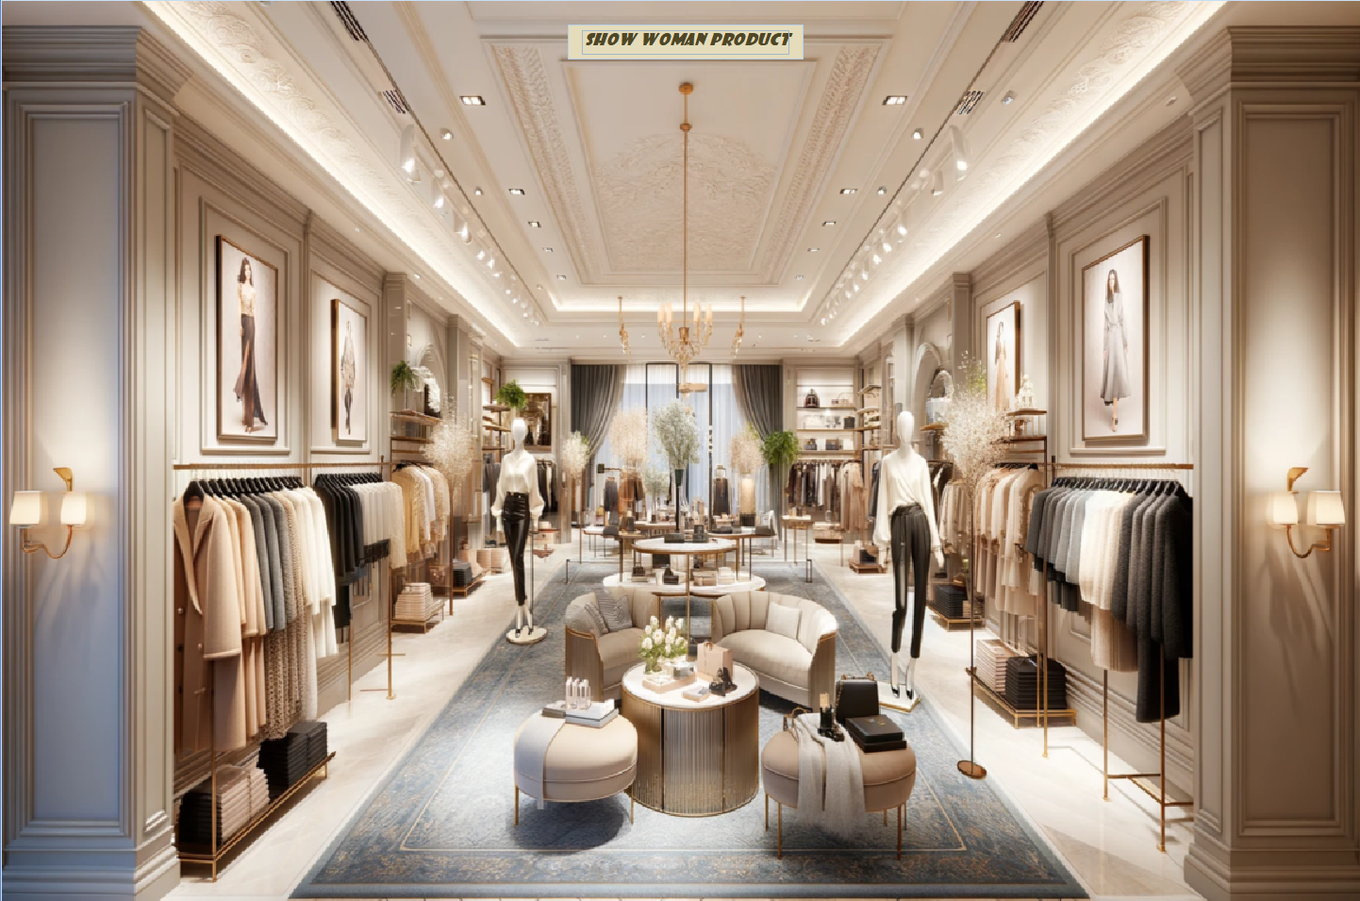If click on (woman) button

If click on (Show woman product) button

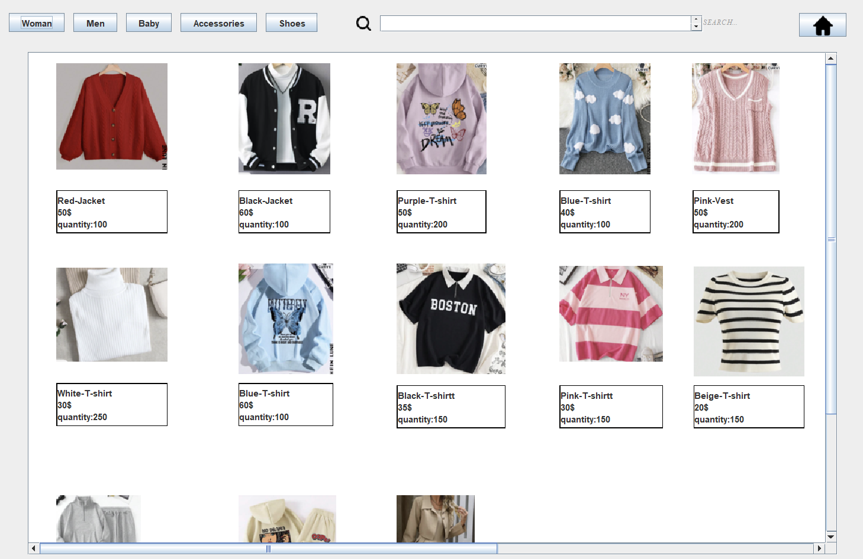

If click on (Men) button

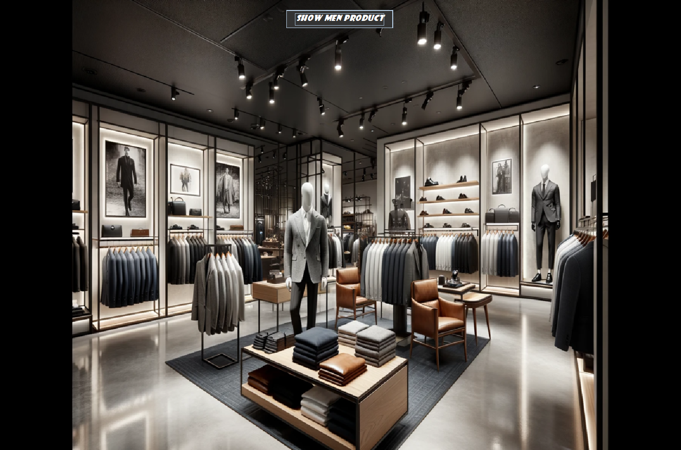

If click on (Show men product) button

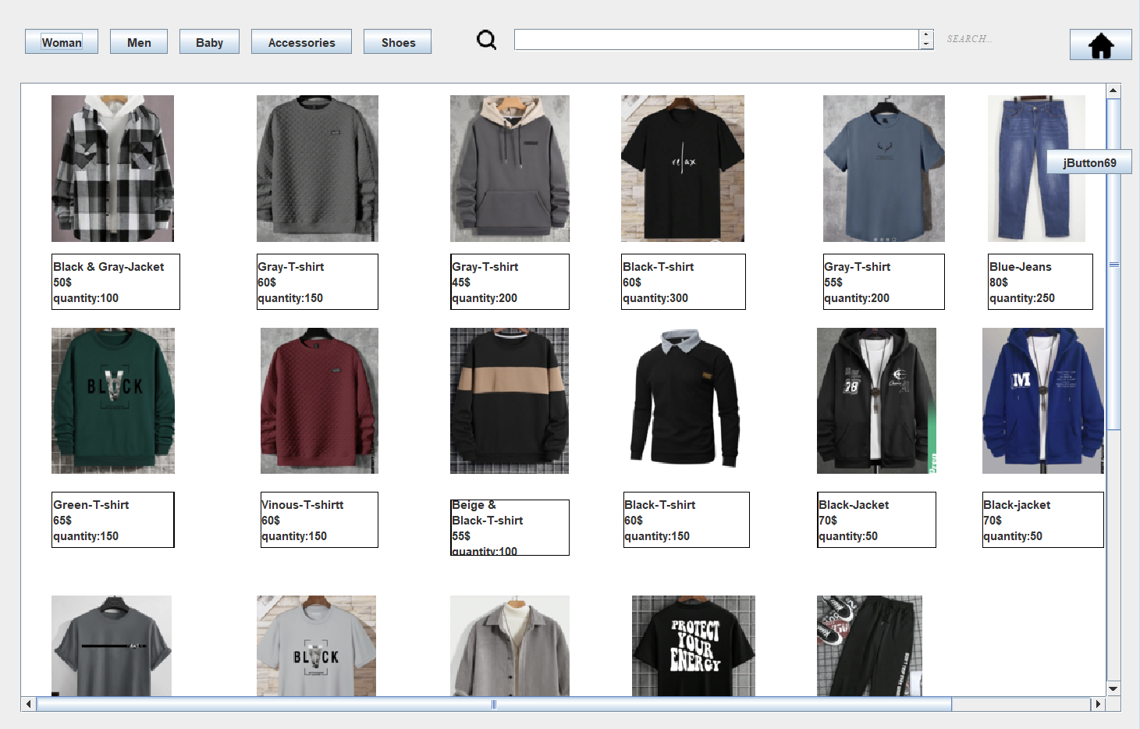

If click on (Baby) button

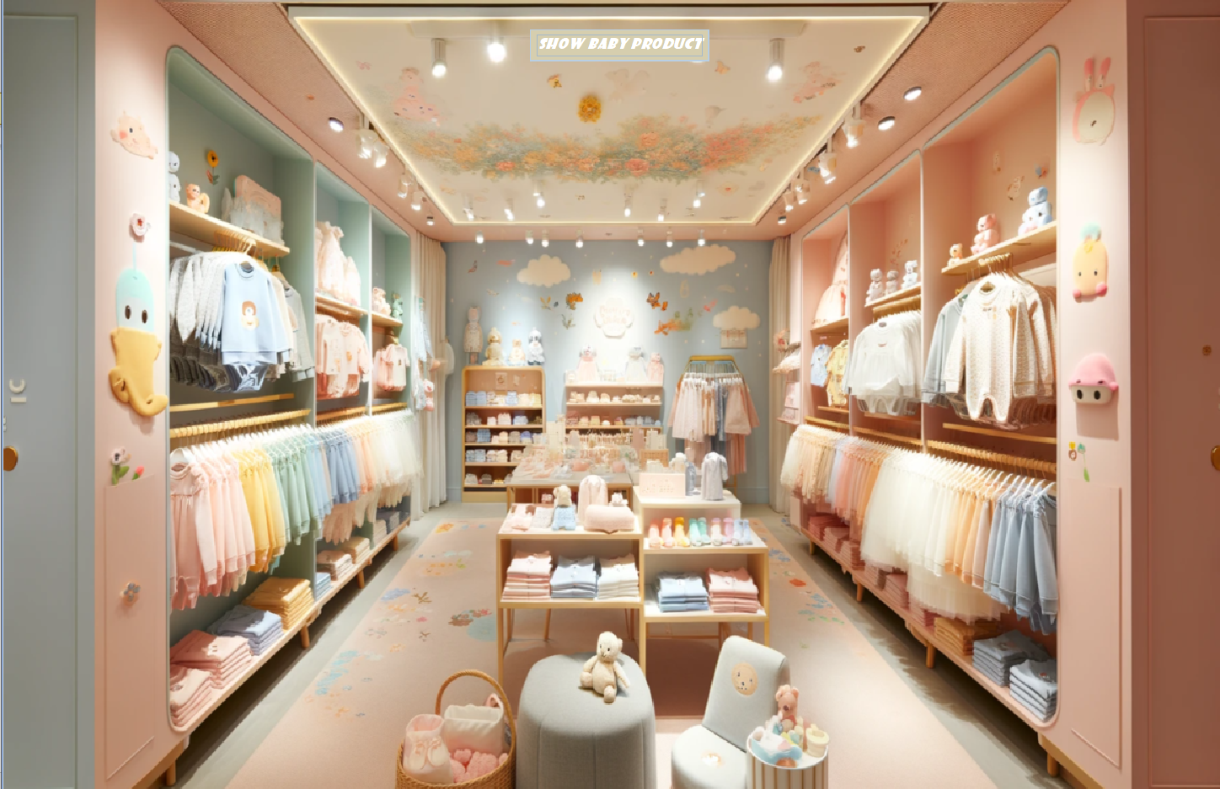

If click on (Show baby product) button

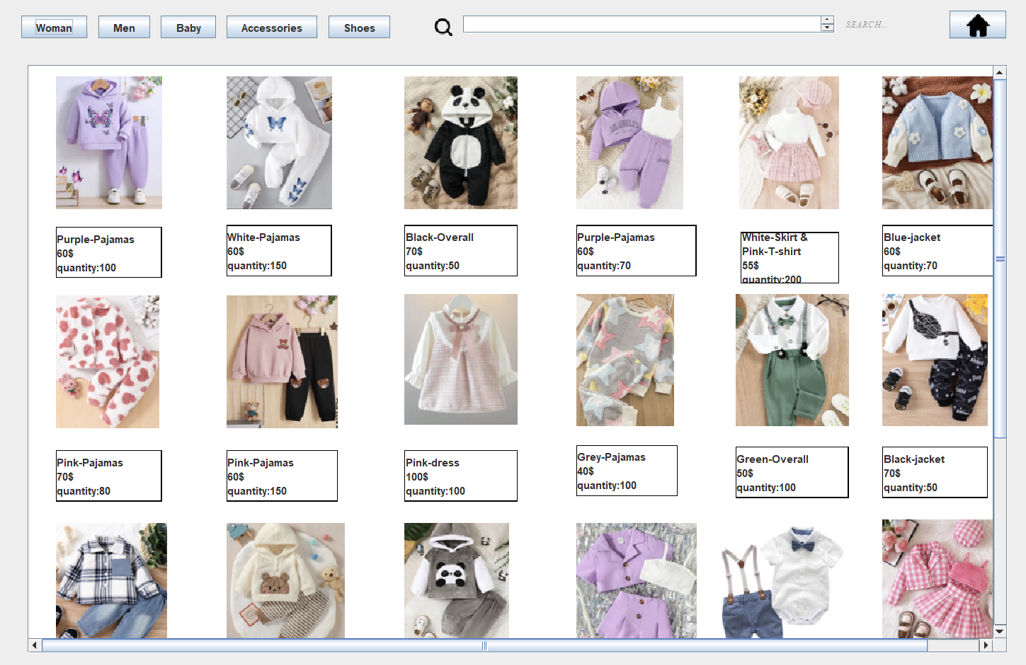

If click on (Accessories) button



If click on (Show accessories product) button

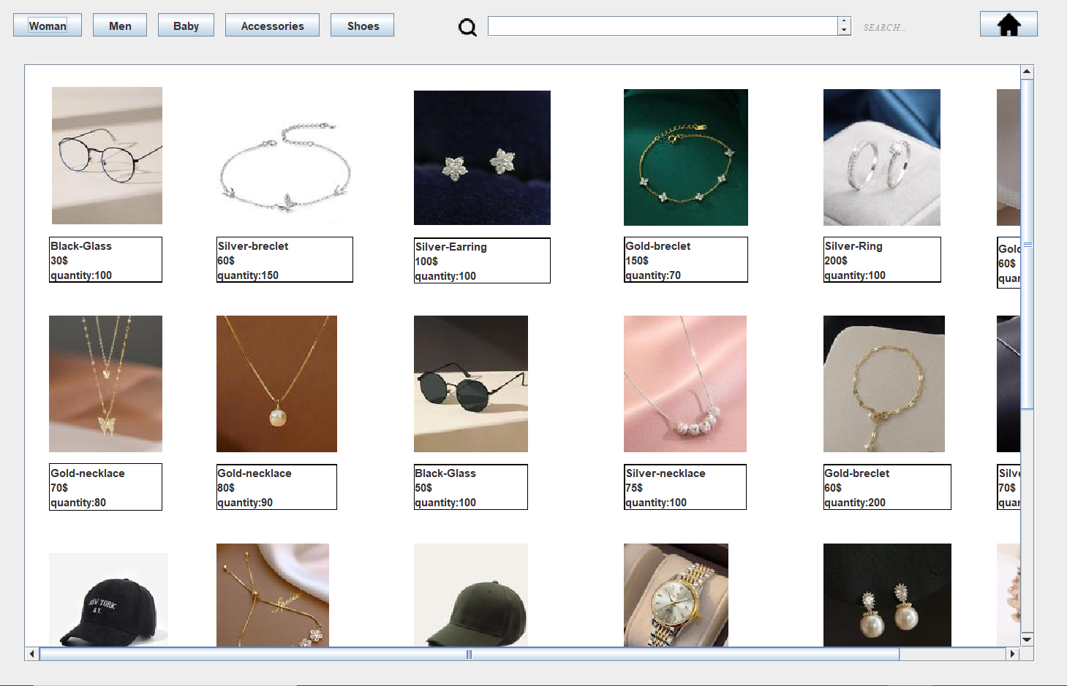

If click on (Shoes) button

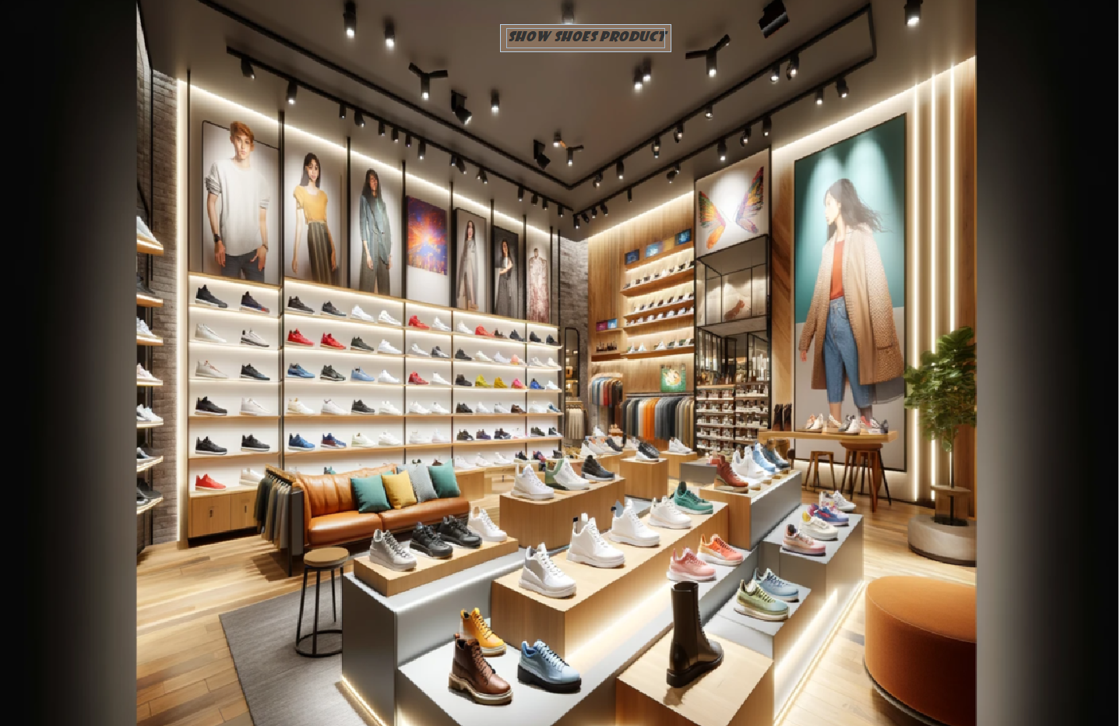

If click on (Show shoes product) button

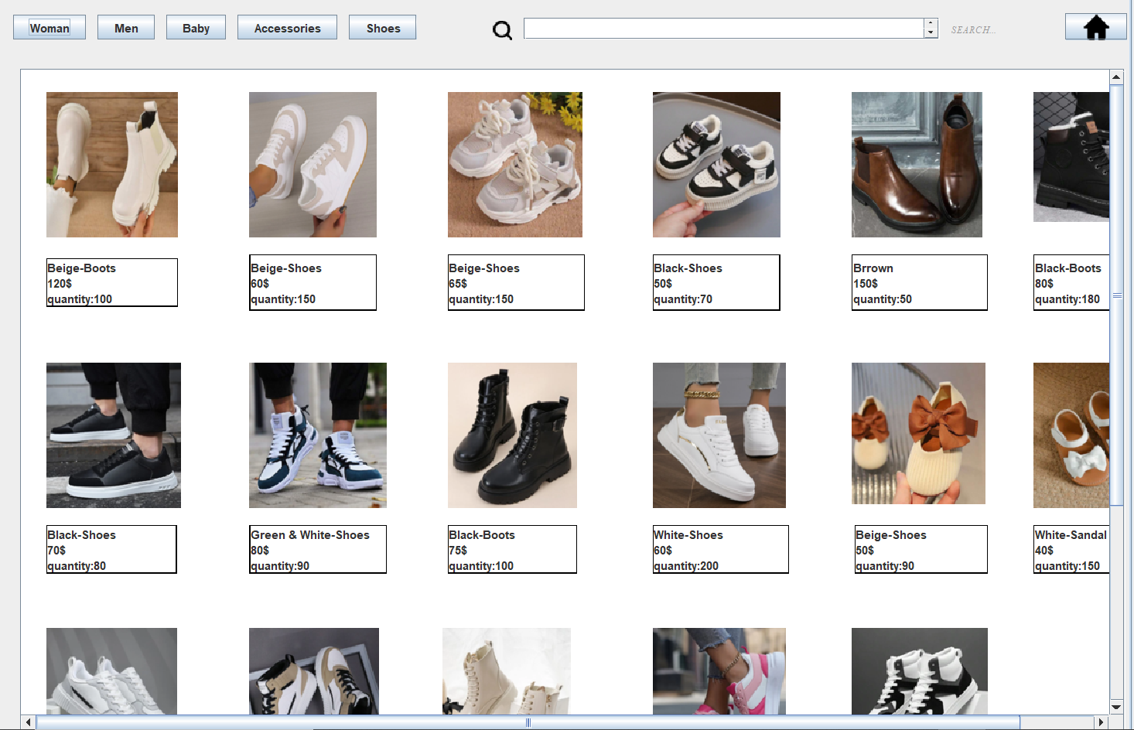



In each photo if I pressed on 🡪 move to home page.

If I back to home page then click on (Report) button then will design the report in (.pdf) and calculation the # of product and employee in each department.

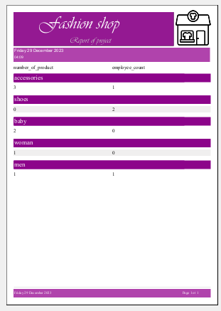for ex. :

Conclusion

We conclude that using the database facilitated the process of storing, retrieving, and modifying data by linking it with GUI.

References

Slides

YouTube & Google

Canva

Geeks for geeks

<https://stackoverflow.com/>

For some picture

<https://www.flaticon.com/>

to resize picture

<https://www.iloveimg.com/resize-image#resize-options,pixels>

<https://www.onlineconverter.com/resize-image>